1. Light weight, OO programming language.
2. Datatypes are numbers, strings, Boolean, undefined (value not assigned to variable yet) and null (non-existent). JS is dynamically typed. Camel case is used for naming variables. JS automatically does ***type coercion*** i.e.  
     
   **This gives an error in Python**

age = 28

name = 'Jaydeep'

print(name + ' ' + age)  
  
**BUT WORKS PERFECTLY FINE IN JS BECASUSE OF TYPE COERCION**age = 28

name = 'Jaydeep'

console.log(name + ' ' + age);

***== will perform type coercion eg. 23 == ‘23’ will be true.***

***=== will not perform type coercion eg 23=== ‘23’ will be false because string not equal to integer***

**IF-ELSE**

Takes the following forms  
  
if(condition){

}

If(condition){  
}else{

}

if(condition){

}else if(condition){

}else{

}

**TERNARY OPERATOR**

1. This is still like an if-else block but all in one line and take the following form  
     
   if condition ? do something : else do something else

Age >= 18 ? console.log(can drink) : console.log(cannot drink)

**SWITCH**

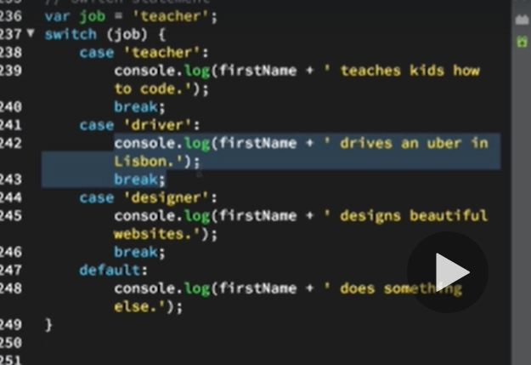

**TRUTHY AND FALSEY**

1. Falsey values are : NULL, UNDEFINED, NaN, 0, ‘’
2. TRUTHY values are all those which are not FALSEY.

**FUNCTIONS**

1. Use camelCase for naming.

**Arrays**

1. var nameArray = [‘Tinkya’,’Jaydeep’,’Chaitu’];
2. var nameArray = new Array(‘Tinkya’,’Jaydeep’,’Chaitu’);
3. zero indexed.
4. Arrayname.length will give length
5. **Push()** can be used to add element to the end of the array.
6. **Pop()** will remove the last element.
7. **Unshift()** will add element to start of array
8. **Shift()**  will remove the first element
9. **indexOf(element)** will give index of element which is passed and returns -1 if element is not present. A nice use case of this is as below  
     
   var isDesigner = johnArray.indexOf(‘designed’) === -1 ? ‘John is a designer’ : ‘John is not a designed’  
     
   console.log(isDesigner)

**Objects**

1. Javascript objects store data in key value pairs.  
     
   var jaydObject = {  
    name : ‘Jaydeep’,  
    age : 30,  
    profession : ‘’DESIGNER’,  
    family : [‘Jaywant’,’Chaitu’,’Mummy’,’Tinkya’]  
   }
2. to change values we can simply reference the object as jaydObject.profession = ‘FOOTBALLER’ or jaydObject[‘age’] = 900
3. Another way to create a object is   
   var jaydObject = new Object()  
   jaydObject.name = ‘Jaydeep’  
   jaydObject.profession = ‘DESIGNER’
4. var jaydObject = {  
    name : ‘Jaydeep’,  
    birthYear : 1989,  
    profession : ‘’DESIGNER’,  
    family : [‘Jaywant’,’Chaitu’,’Mummy’,’Tinkya’]  
    calcAge = function(){  
    return 2019 – this.birthYear;  
      
   }  
   }

console.log(jaydObject.calcAge()); will then give age as this.birthYear will use the birth year from jaydObject

1. var jaydObject = {  
    name : ‘Jaydeep’,  
    birthYear : 1989,  
    profession : ‘’DESIGNER’,  
    family : [‘Jaywant’,’Chaitu’,’Mummy’,’Tinkya’]  
    calcAge = function(){  
    ***this.age = 2019 – this.birthYear;***   
   }  
   }

jaydObject.calcAge() – notice the use of this keyword and now when we output the same age will be a field in the jaydObject

*console.log(jaydObject)  
  
{  
 name : ‘Jaydeep’,  
 birthYear : 1989,  
 profession : ‘’DESIGNER’,  
 family : [‘Jaywant’,’Chaitu’,’Mummy’,’Tinkya’]  
 age : 31* *}  
}*

**LOOPS**

1. ***for (var I = 0; i< 10; i++){}***
2. ***typeof*** keyword is used to determine the type of the data.

**BTS OF HOW JS IS EXECUTED**

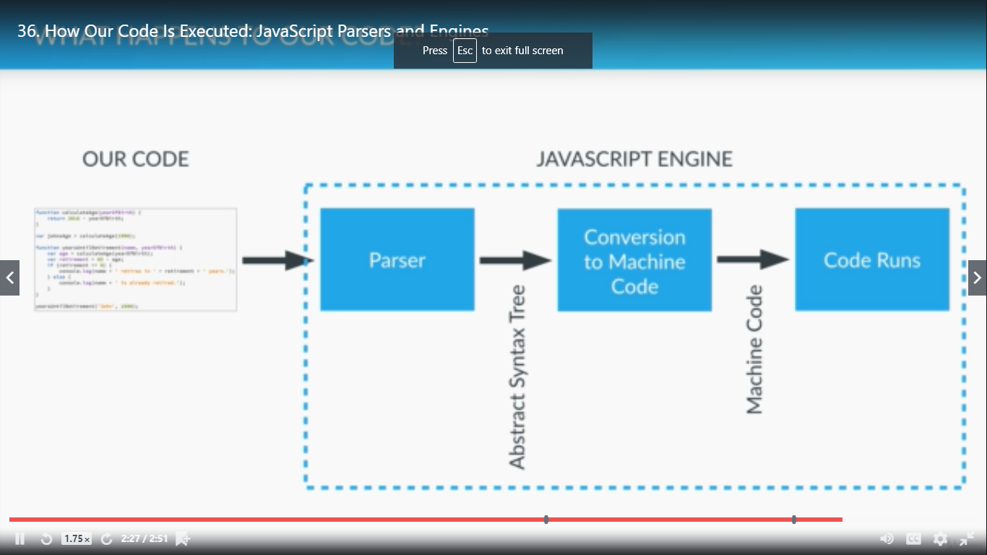

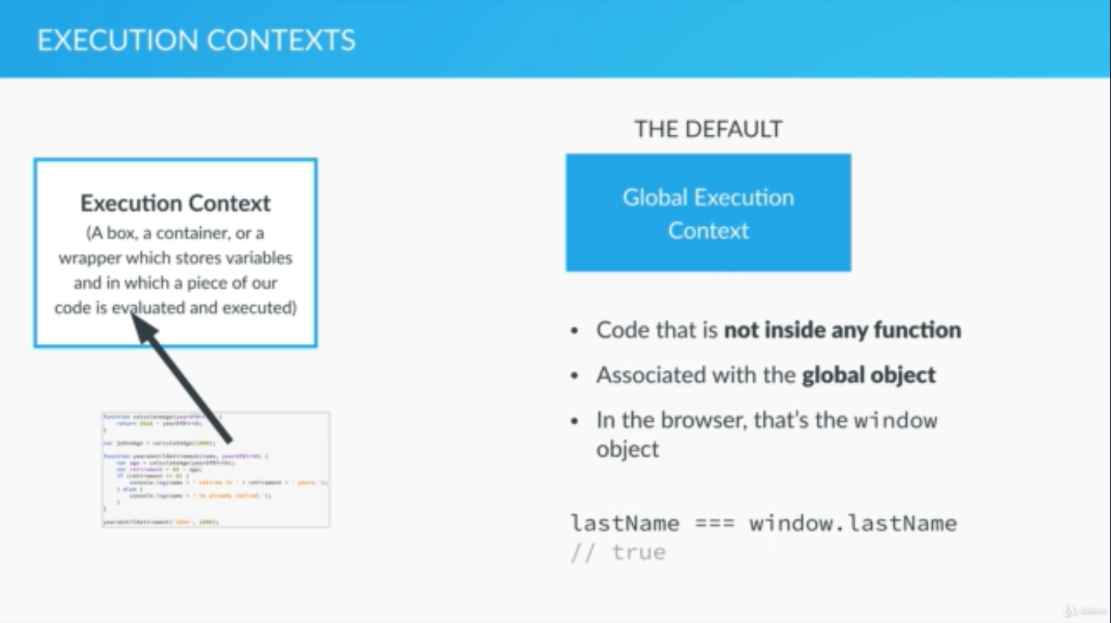

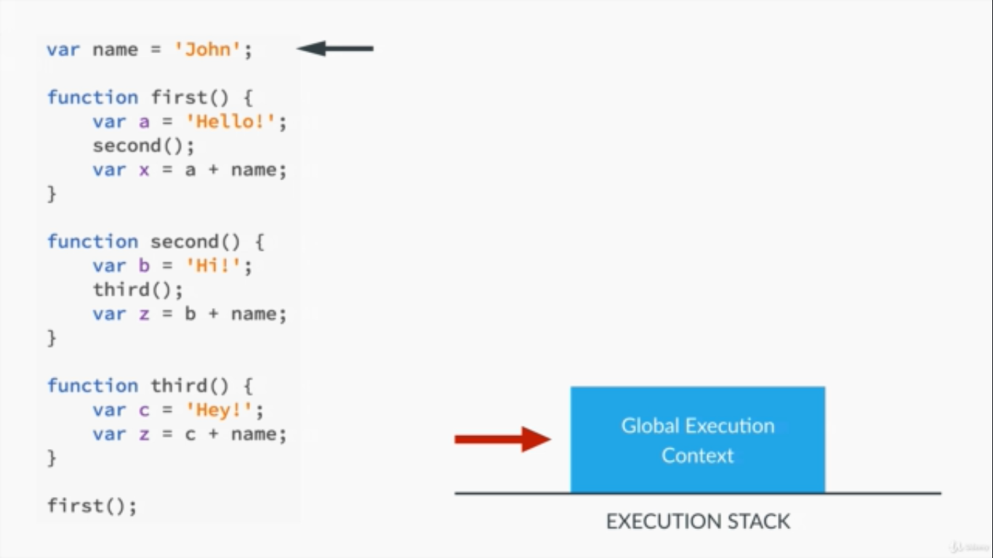

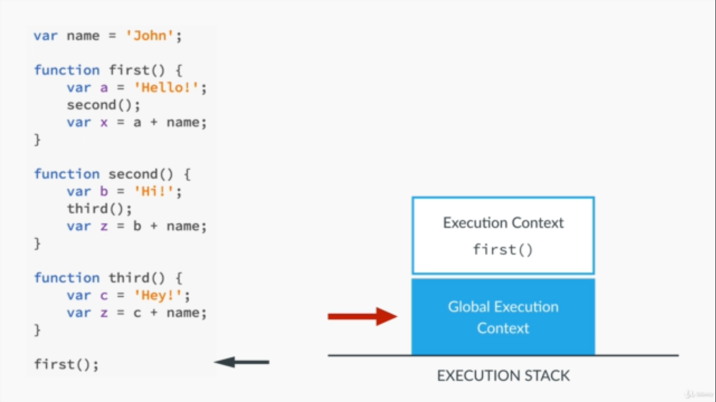

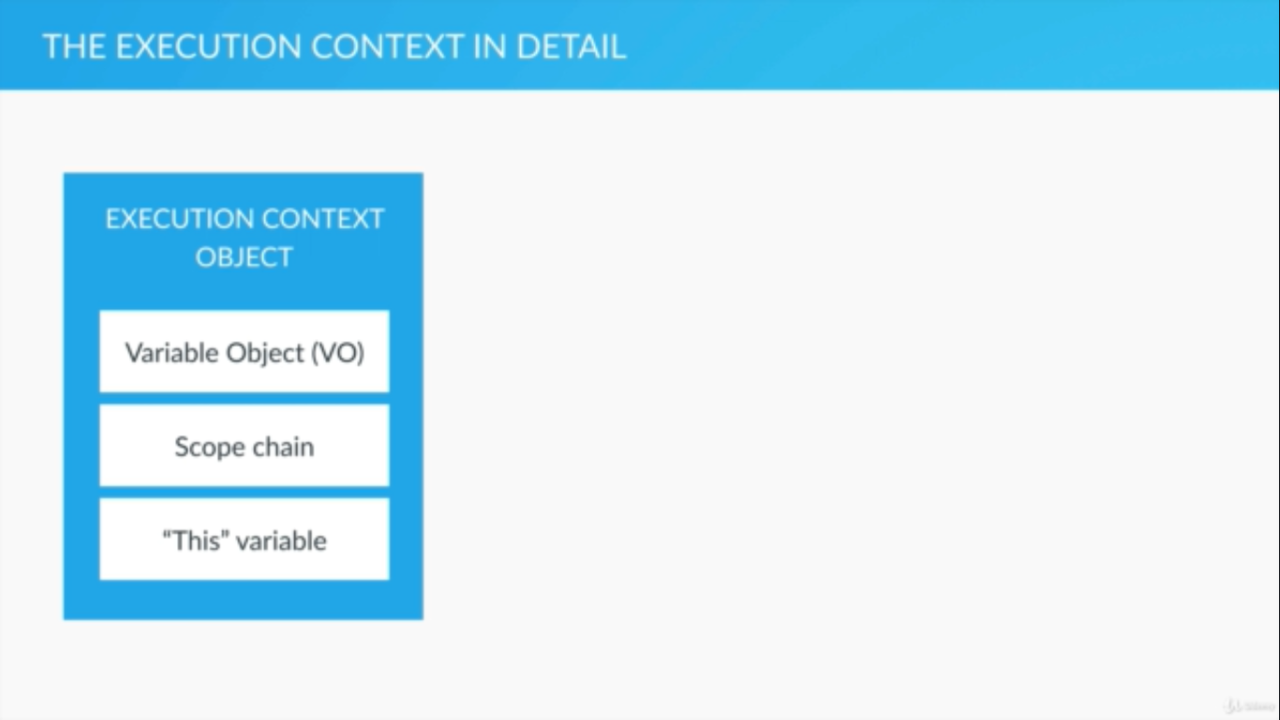

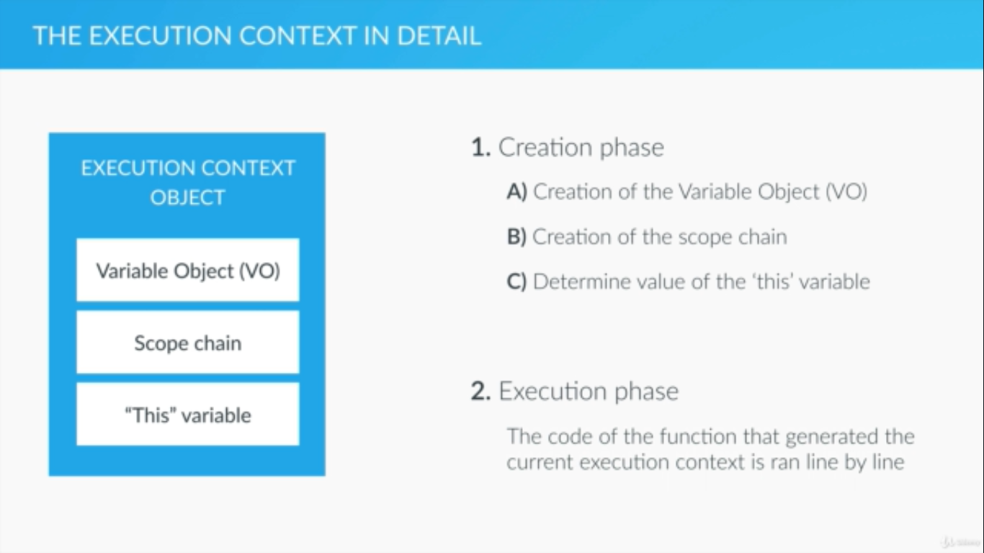

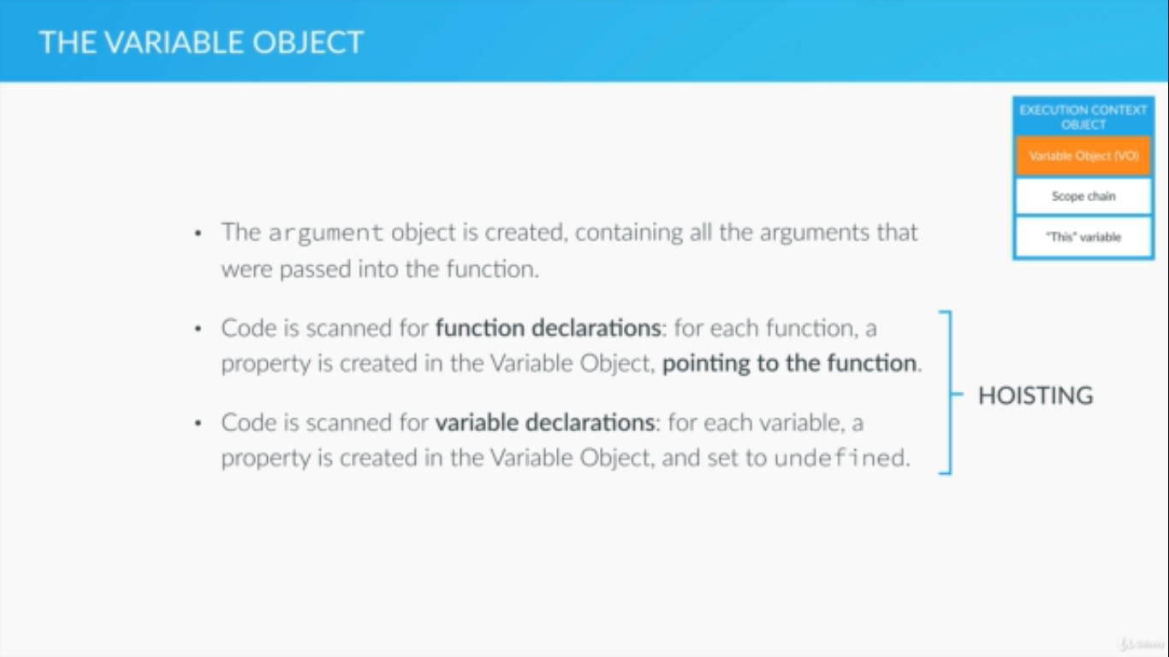

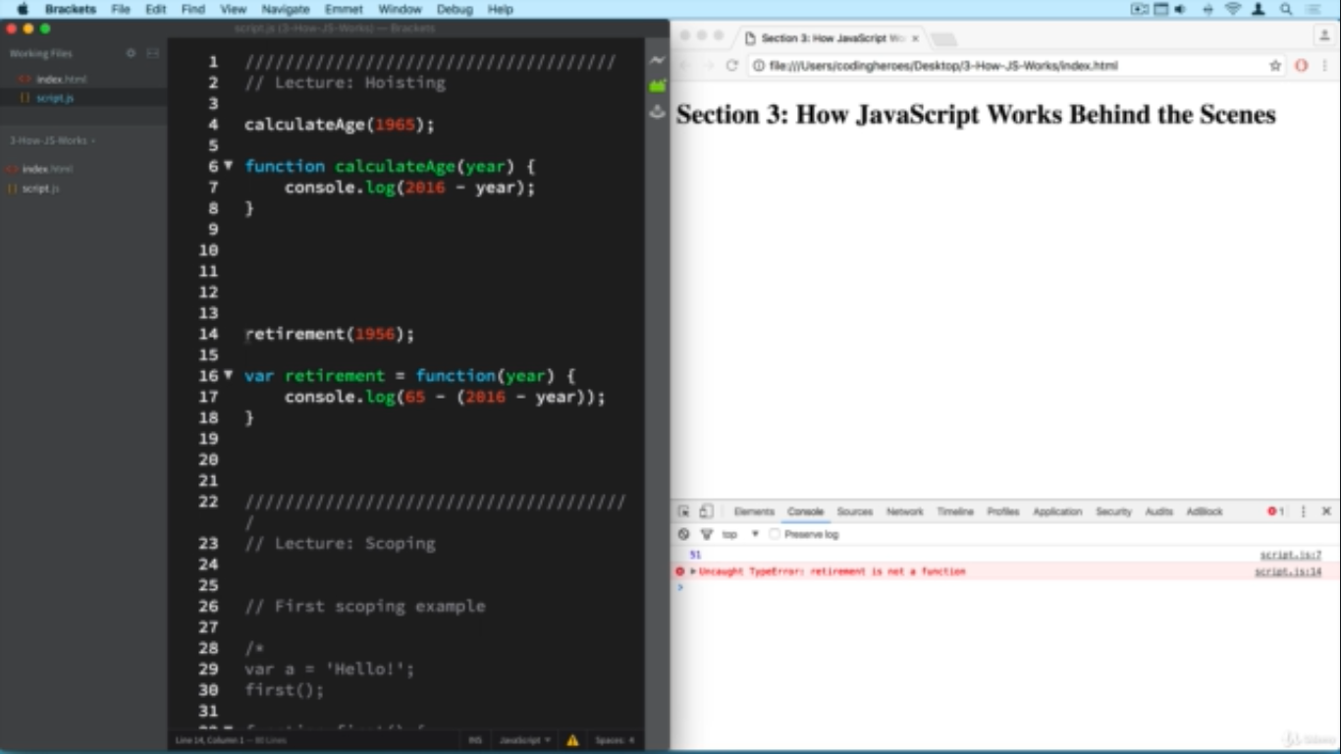

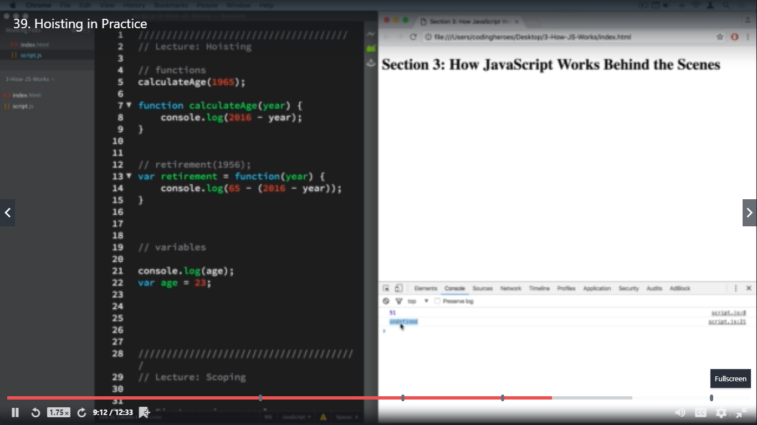

**In the above screenshot the result is UNDEFINED because JS know that variable age exists bt just doesn’t know it’s value yet.**



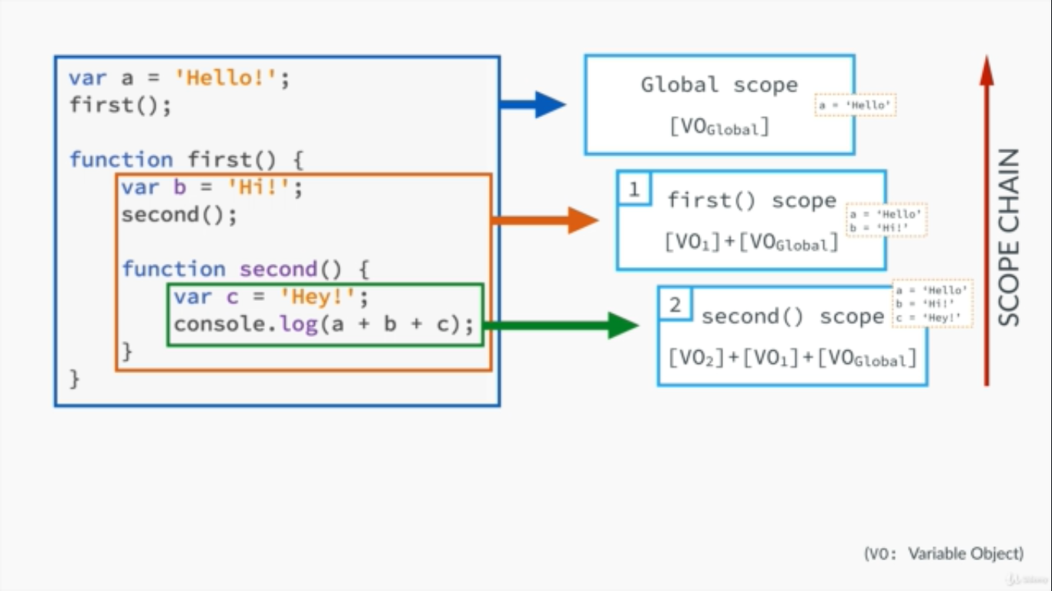

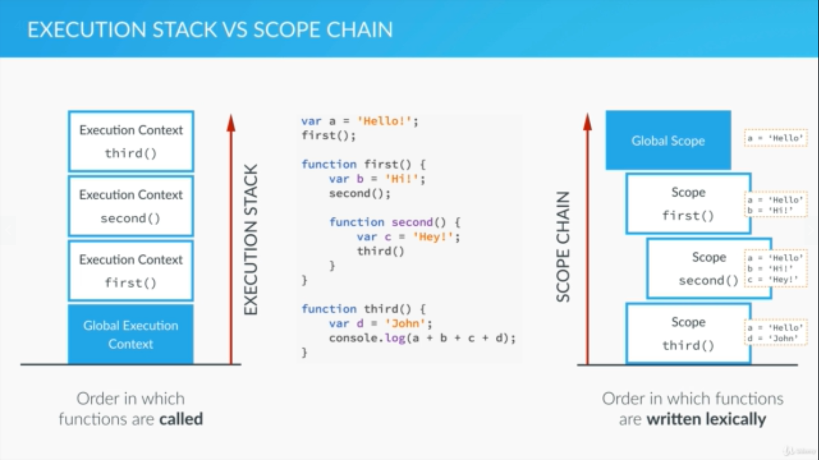

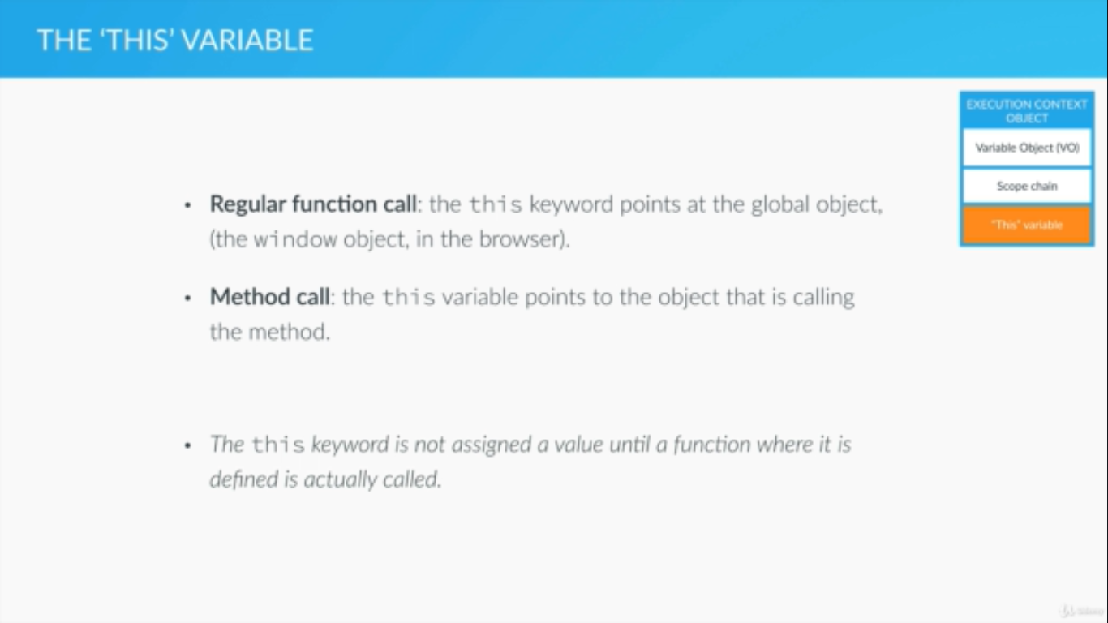

**The below slide is very important, see how the this keyword when used with MiKE object prints the mike object even though the calculateAge is a method of the John object**

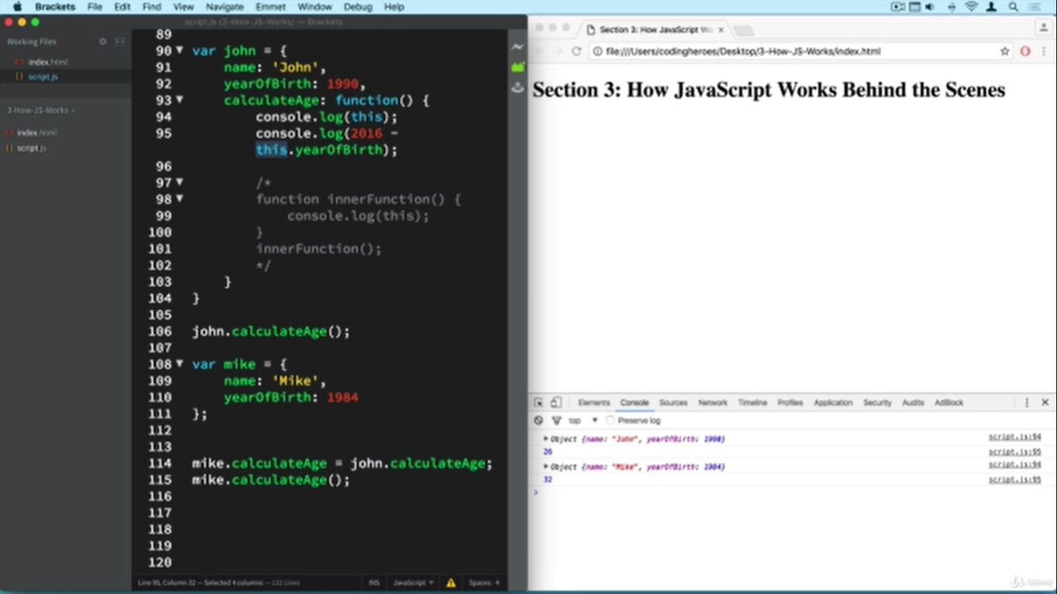

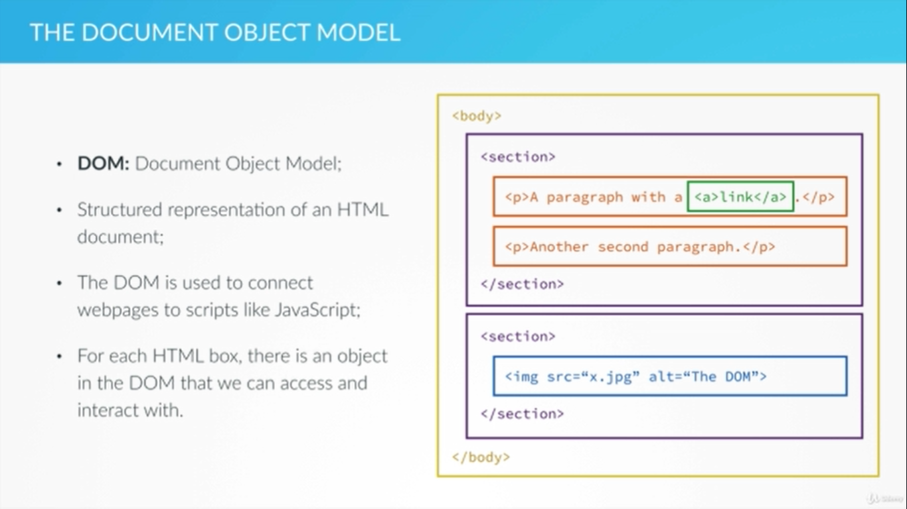

1. document.querySelector() is a new feature which works the same as document.getElementByID or getElementByClass.
2. document.querySelector(‘#id’).textContent = ‘Hello’ will change the div with id = ‘id’ to Hello
3. document.querySelector(‘#id’).innerHTML = ‘<em>’ + ‘Hello’ + ‘<em>’ will print HELLO in italic

**EVENTS and EVENT HANDLING**

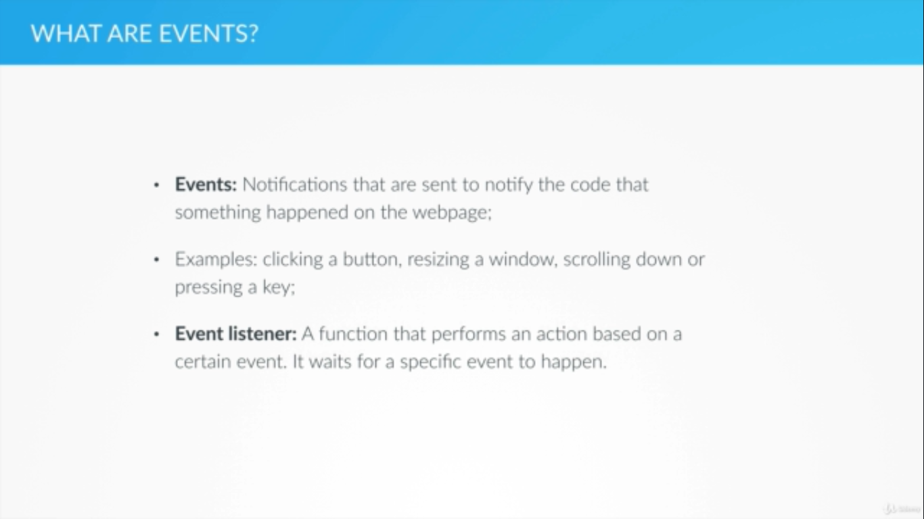

**OBJECTS AND FUNCTION**

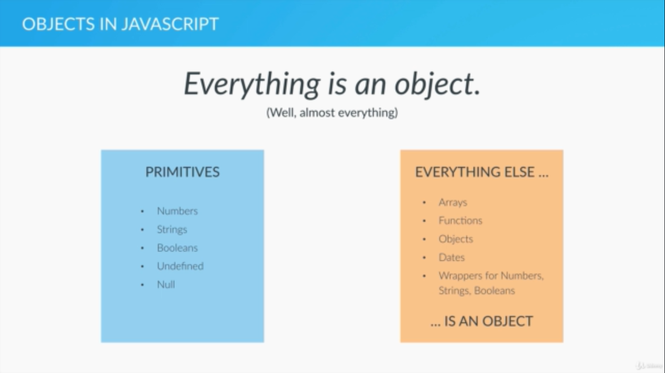

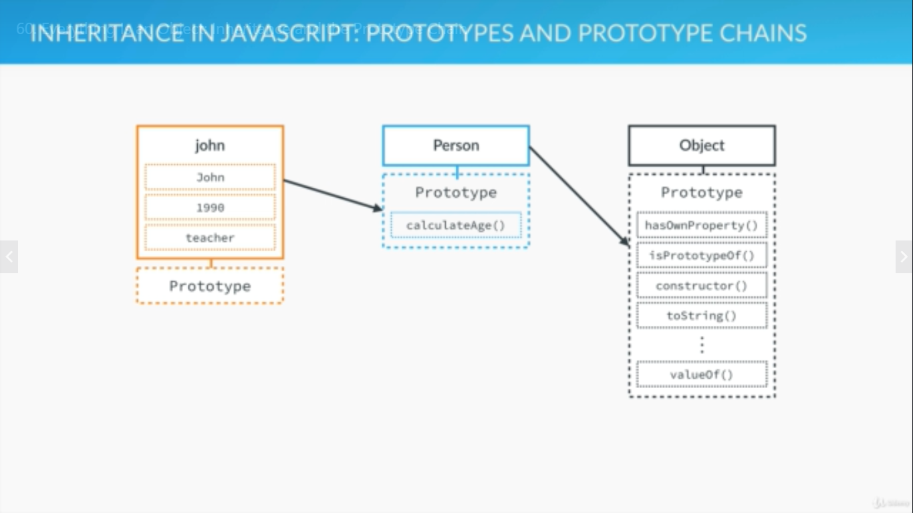

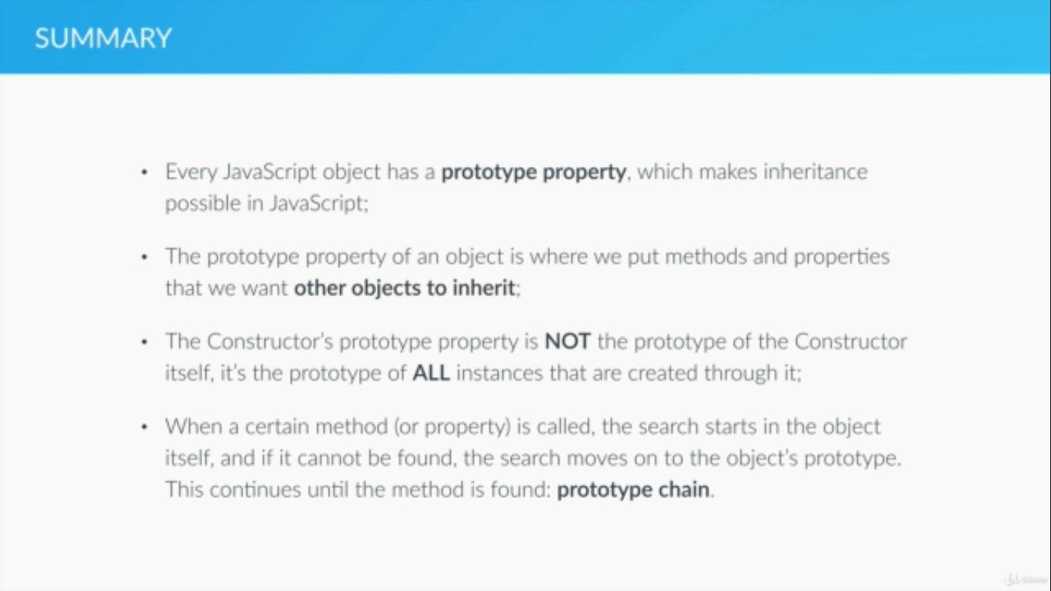

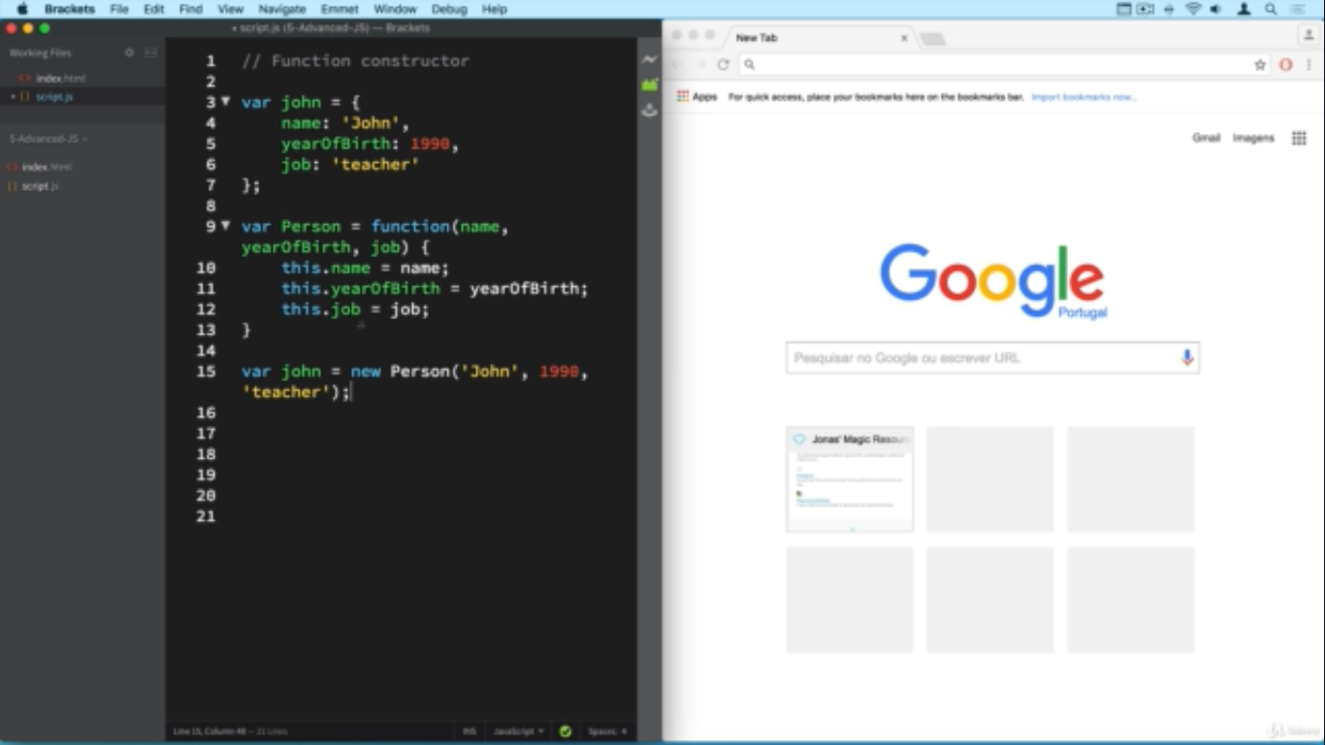

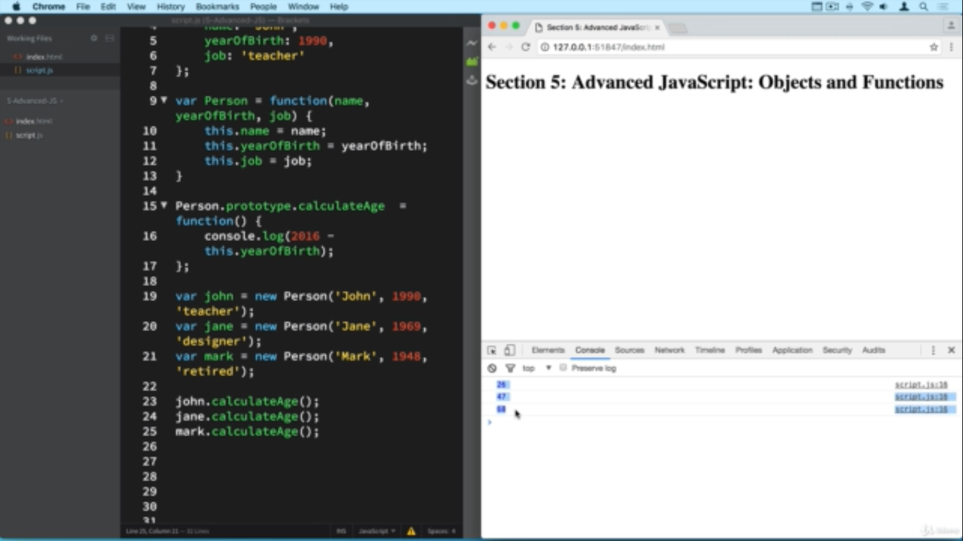

IN the below slide is highlighted the difference between PRIMITIVES and OBJECTS. As you can see when we assign one PRIMITIVE to the other it acts as a separate entity and hence when we change a, b does not change.

In case of OBJECTS however assigning one object to the other results in just assigning the reference to the same object and hence when we change value in one object it reflects in other object too.

In summary PRIMITIVES are pass by value and OBJECTS are pass by reference.

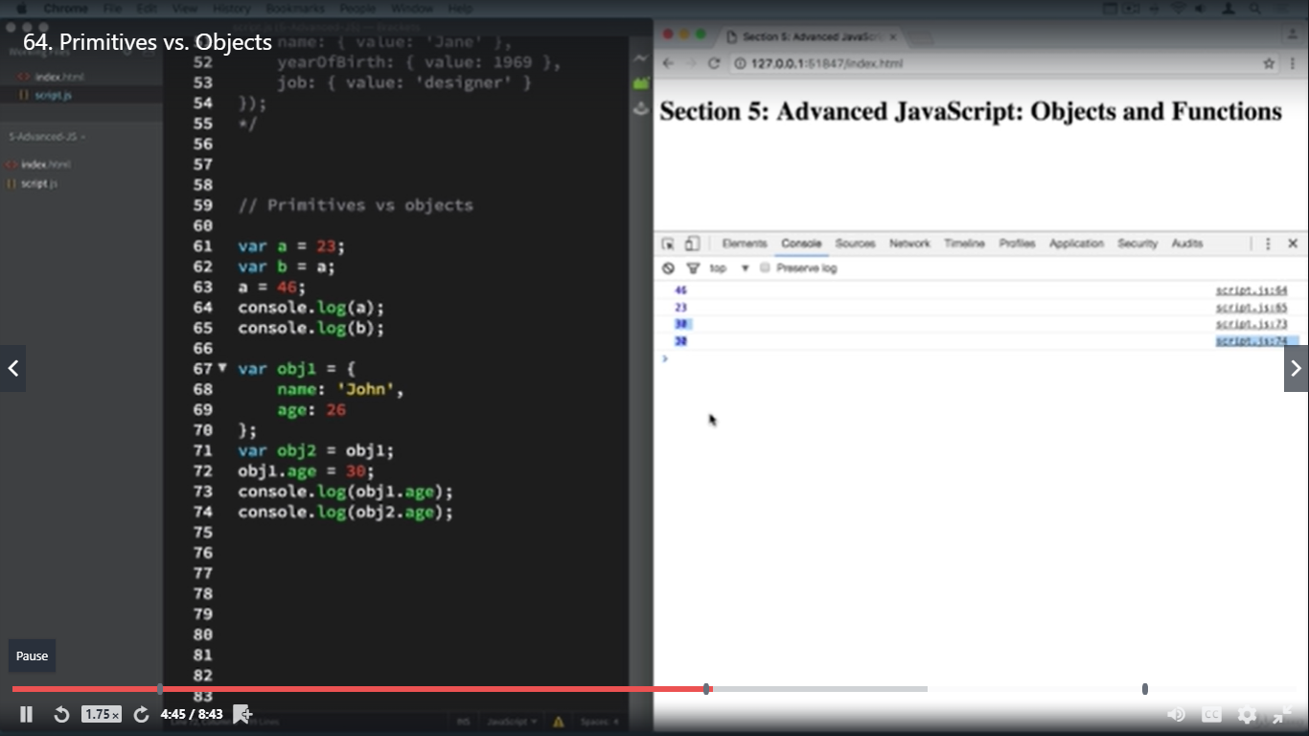

ABOUT FUNCTIONS

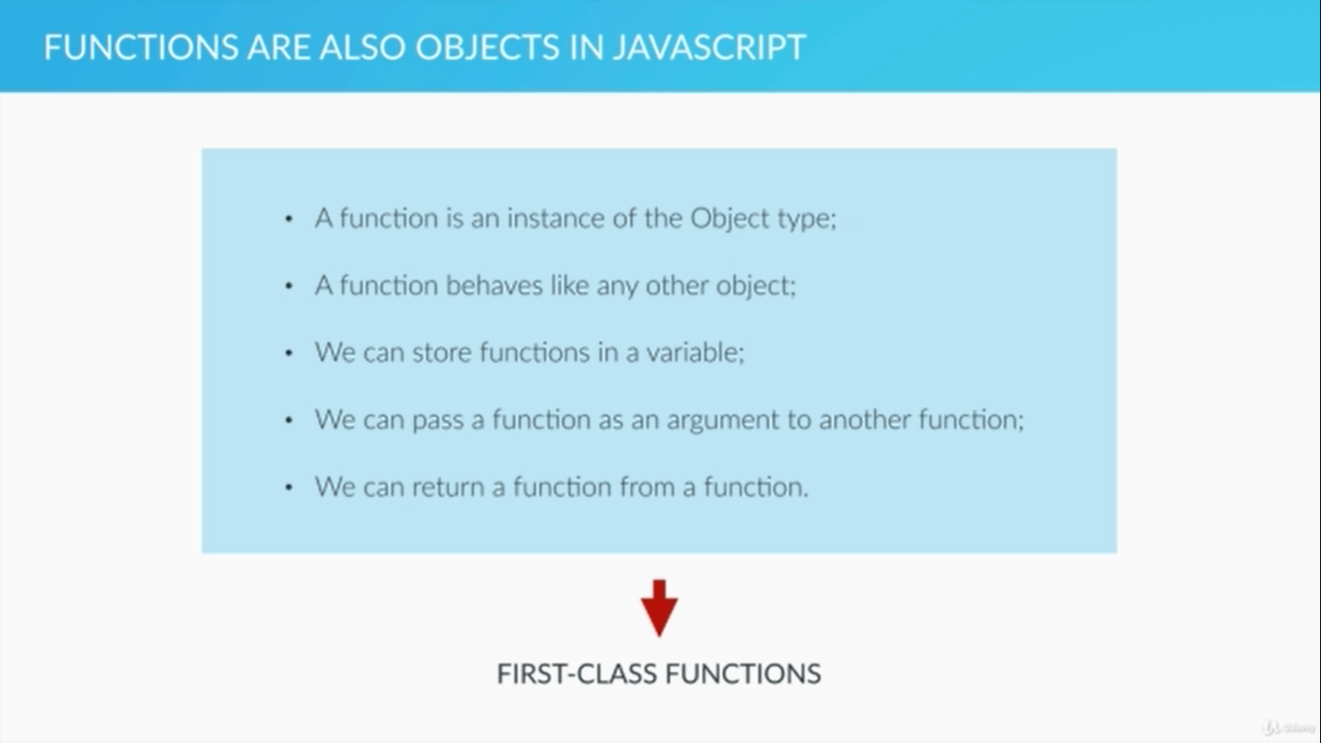

AN IIFE or IMMEDIATELY INVOKED FUNCTION EXPRESSION IS LIKE A FUNCTION WHICH IS DECLARED AND CALLED IN PLACE. NOTICE HOW THE BELOW EXAMPLE IS WRAPPED AROUND IN ROUND BRACKETS AND AGAIN CALLED IN PLACE BY USING ROUND BRACKETS. IIFE IS VERY IMPORTANT TO STRUCTURE CODE AND OBTAIN DATA PRIVACY.

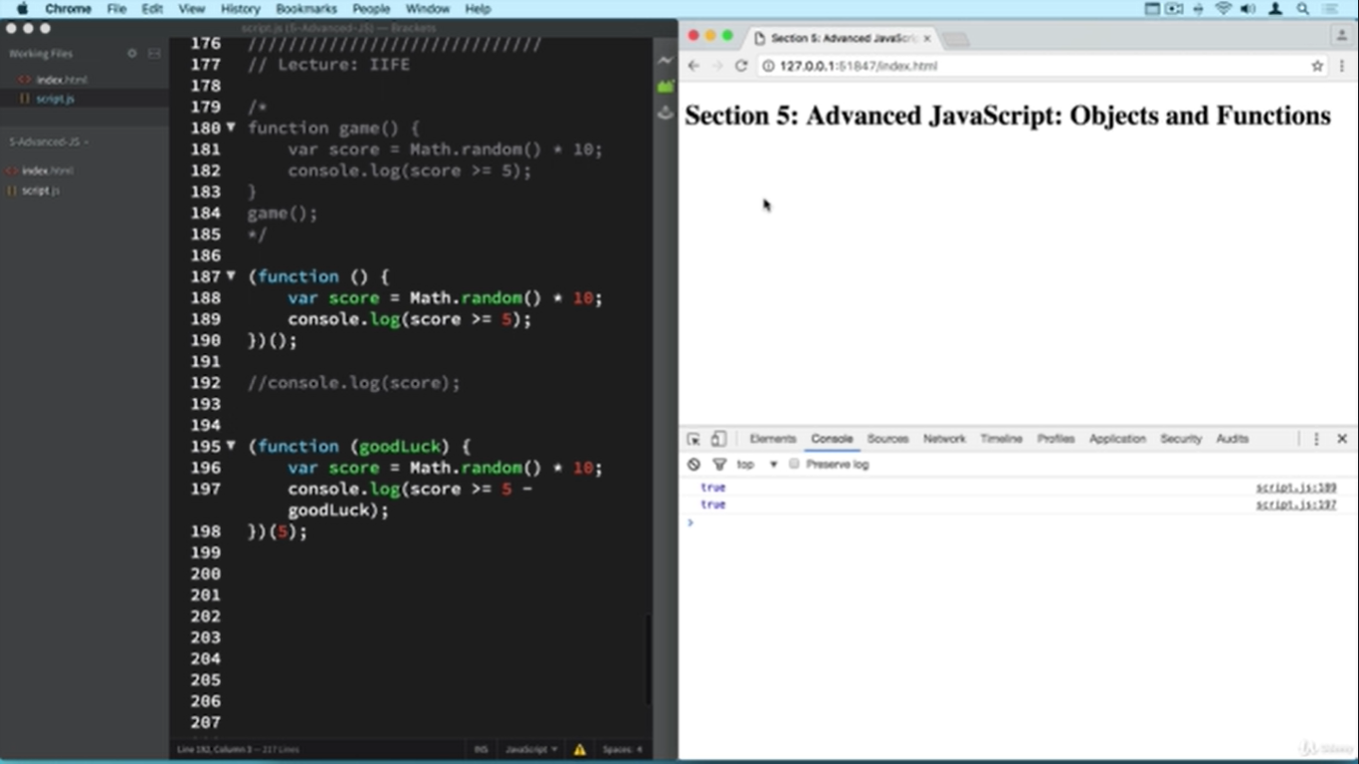

CLOSURES

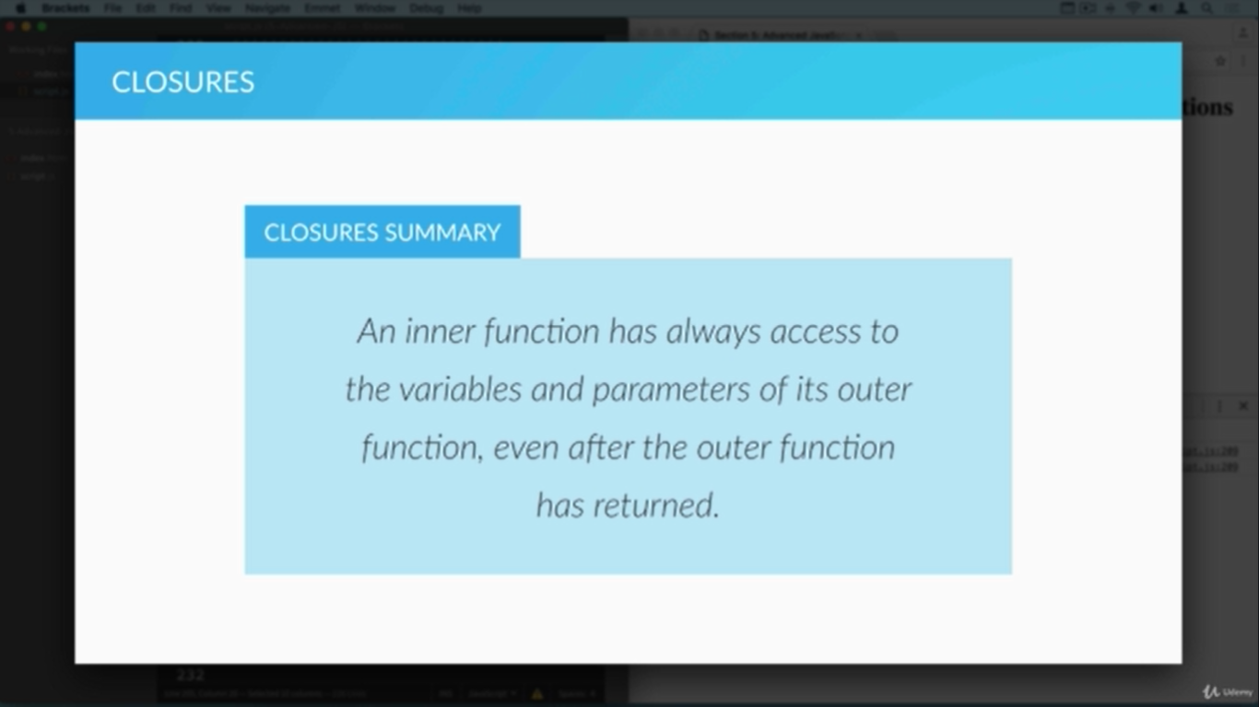

EXAMPLE :- What we have here is that we now have a single anon function which uses the job variable of the outer interviewQuestions function to take decisions and return the appropriate values, this is closure.

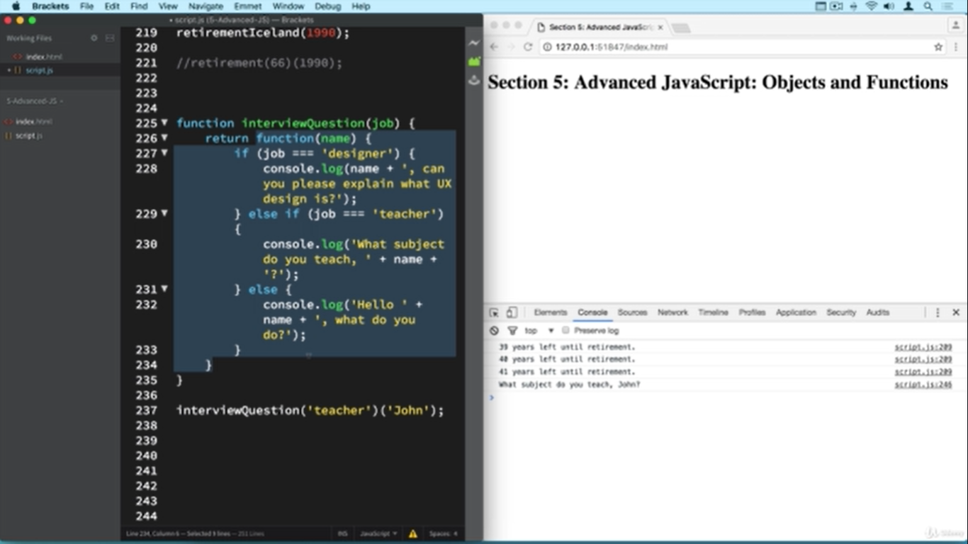

Without Closures this function the above code would like below. Notice how we are using job here and then how efficiently we used it above with closures. Hence closures help us write cleaner and more efficient code.

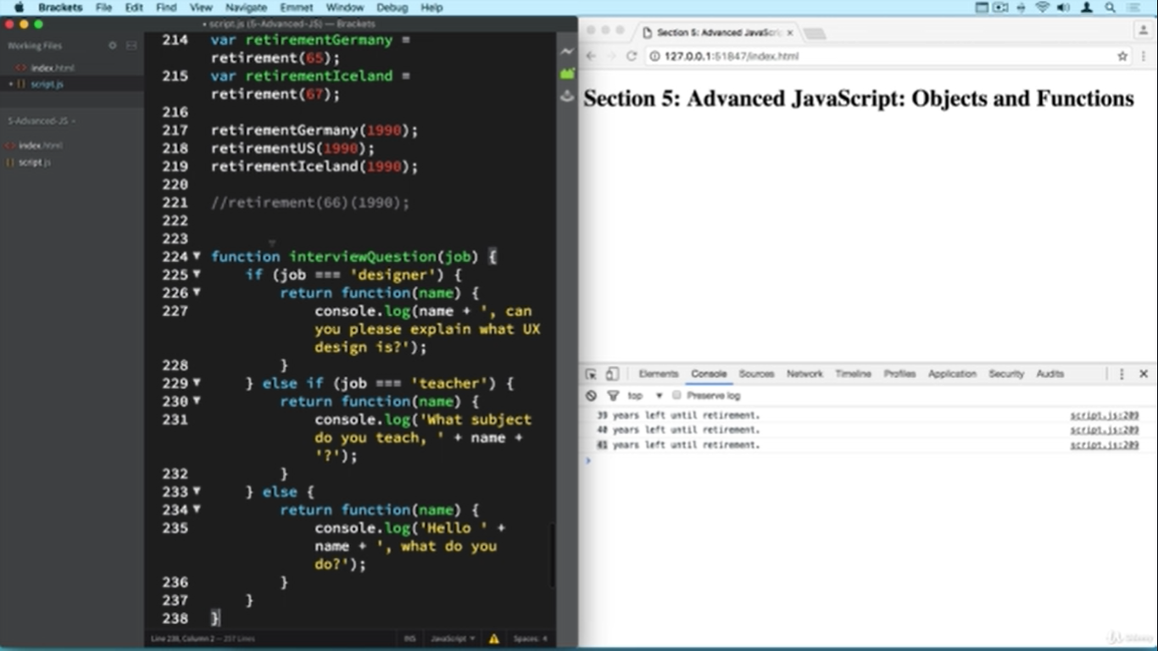

**BIND, CALL and APPLY**

1. METHOD BORROWING :- Notice how Emily doesn’t have the presentation function but by simply passing arguments to the presentation method of John(who has presentation) as Emily, friendly and afternoon and the **using the call() method on it** we can use the presentation function. This is called method borrowing. CALL method allows us to set the this variable of any object. APPLY is like CALL but it takes in an array as input. The BIND() is also like CALL but it generates a copy of the function which can be stored in a variable(function expression) see second screenshot.

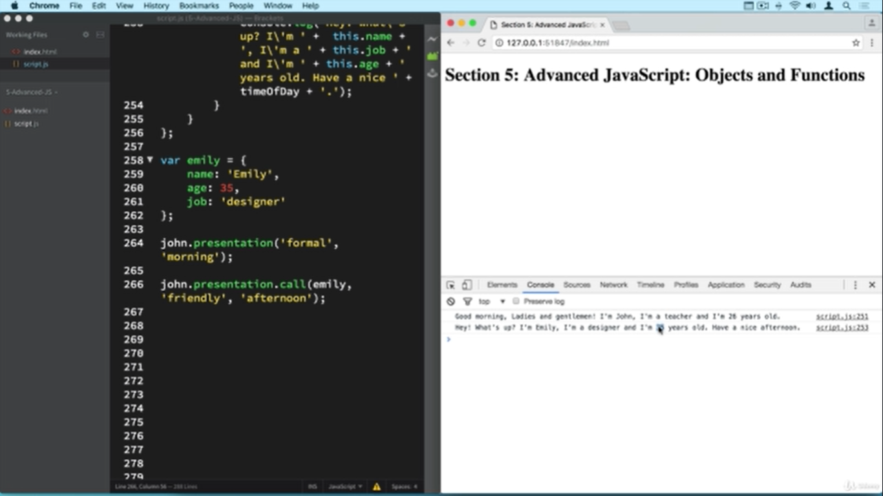

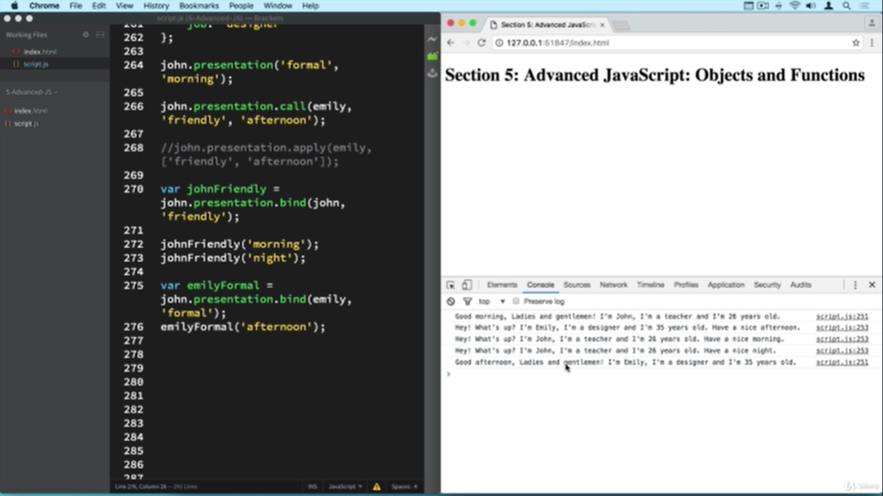

**LET AND CONST**

IN ES6 convention i.e. JS 2015 the let is used in place of var for variables whose values can change and const is used for declaring constants. let variables are block scoped.

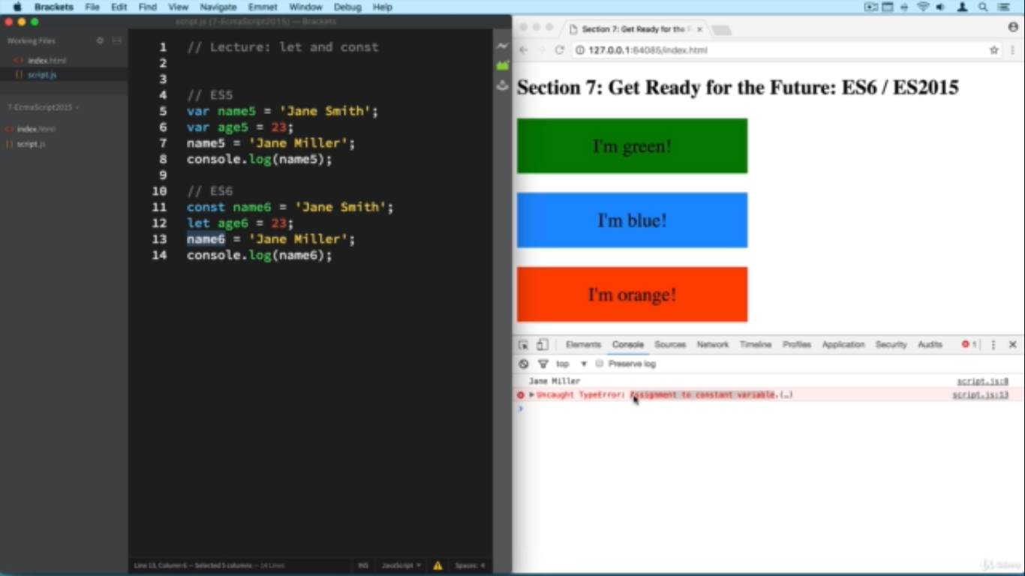

**BLOCK SCOPE EXPLAINED**

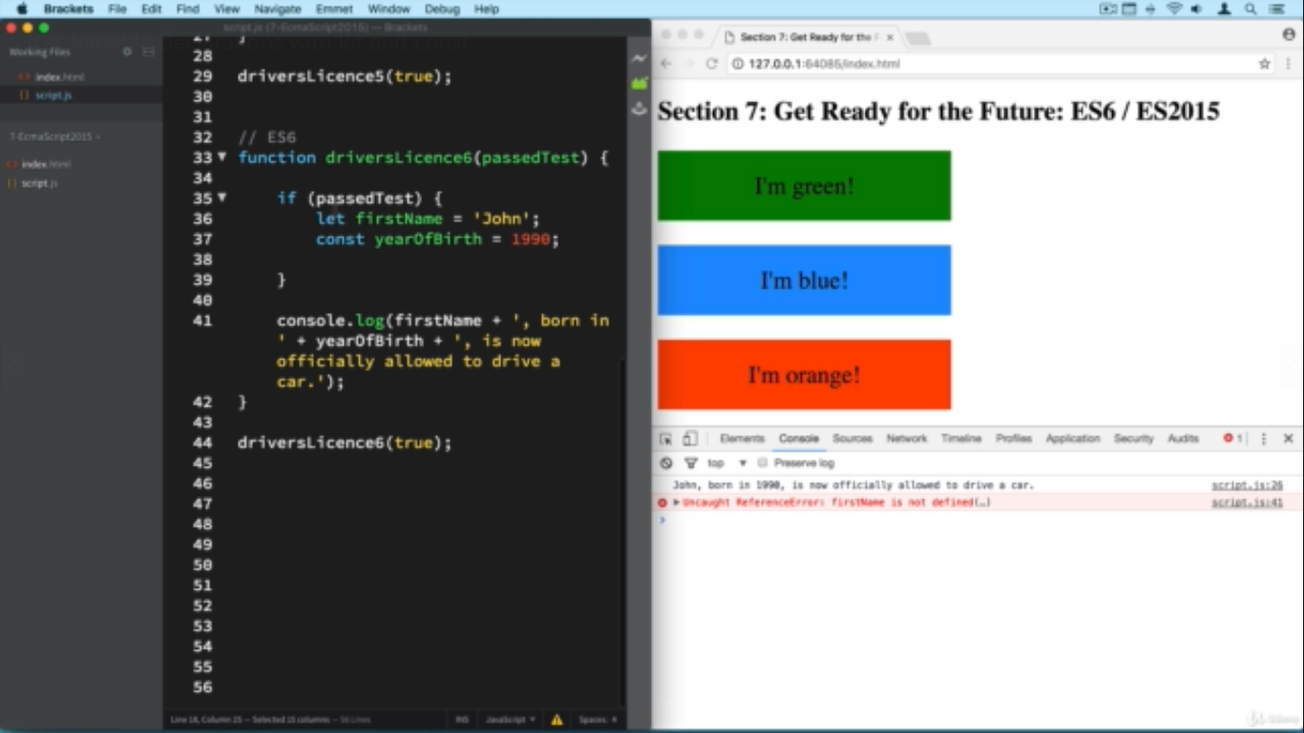

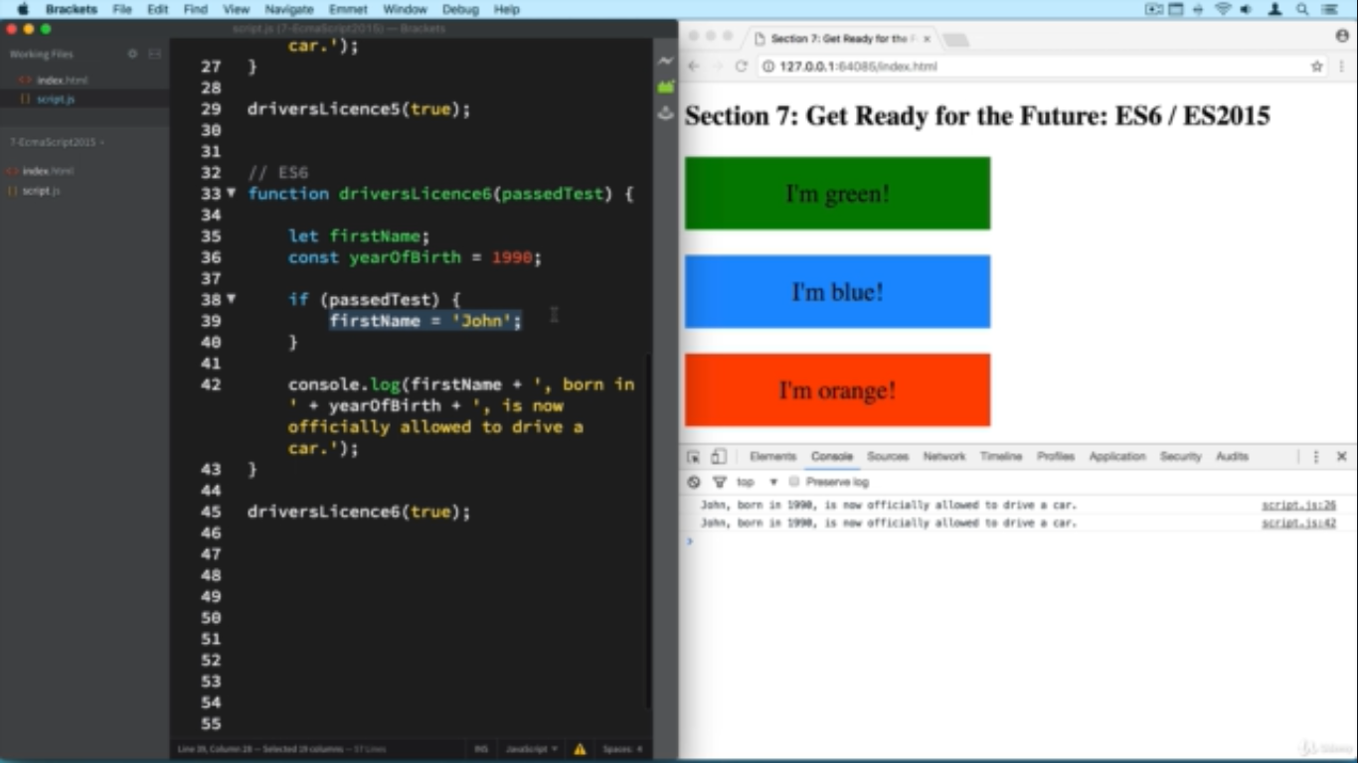

IN BELOW IMAGE PAY ATTENTION TO HOWCONST is declared and defined outside the if block scope. In ES6 you cannot declare constants outside and then defined them inside a block

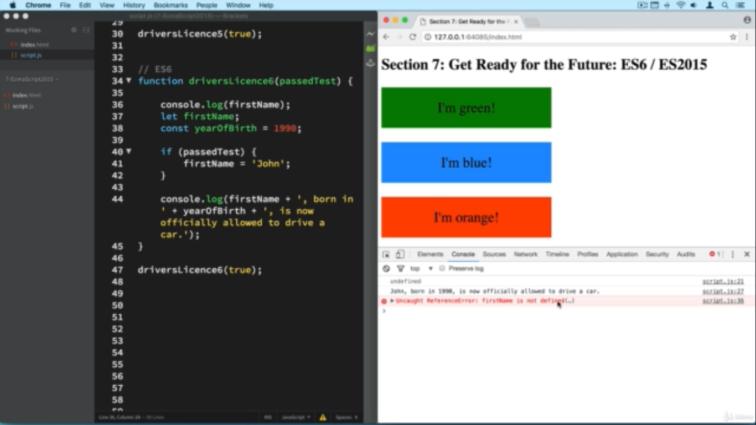

* ES6 has a nice way to format string for printing.
* Console.log(`My name is ${firstName} ${lastName} and I am ${age} years old and have scored ${calCETScore()}.`)
* Some new methods are also available with the string interface

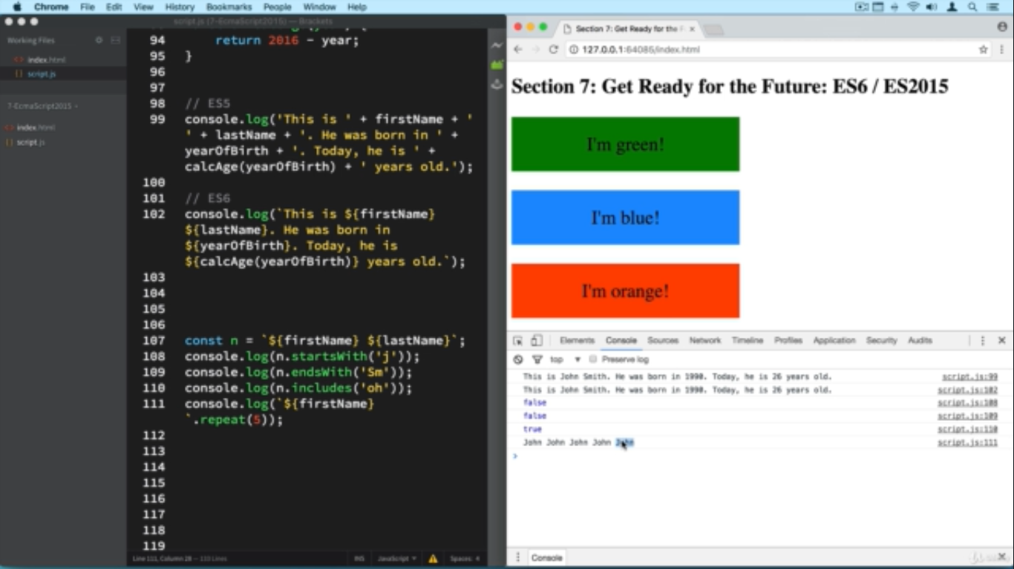

**ARROW FUNCTIONS**

1. More simplified to write.  
     
   let birthYears = [1999, 1989, 1995, 1993]

//single line

let ages = birthYears.map(el => return 2020 - el);

//single line with two arguments

let ages1 = birthYears.map((el, index) => return `Age of ${index +1} is ${2020-el}.s`);

//multiline – notice use of return

let ages1 = birthYears.map((el , index) => {

const now = new Date.getFullYear();

const age = el – now;

return `Age of `${index + } : is ${age}`

});

1. Notice below ES5 implementation where this keyword is not available to the callback function and hence we have used a small hack where var self = this; is declared and we then use the self keyword to access values of position and color inside the callback function. Now why this is needed is because in ES5 the ***this***  keyword will point to global object i.e. window for any non method function(Here clickMe is a method but the callback is not method and hence there the ***this***  keyword points to the browser window)

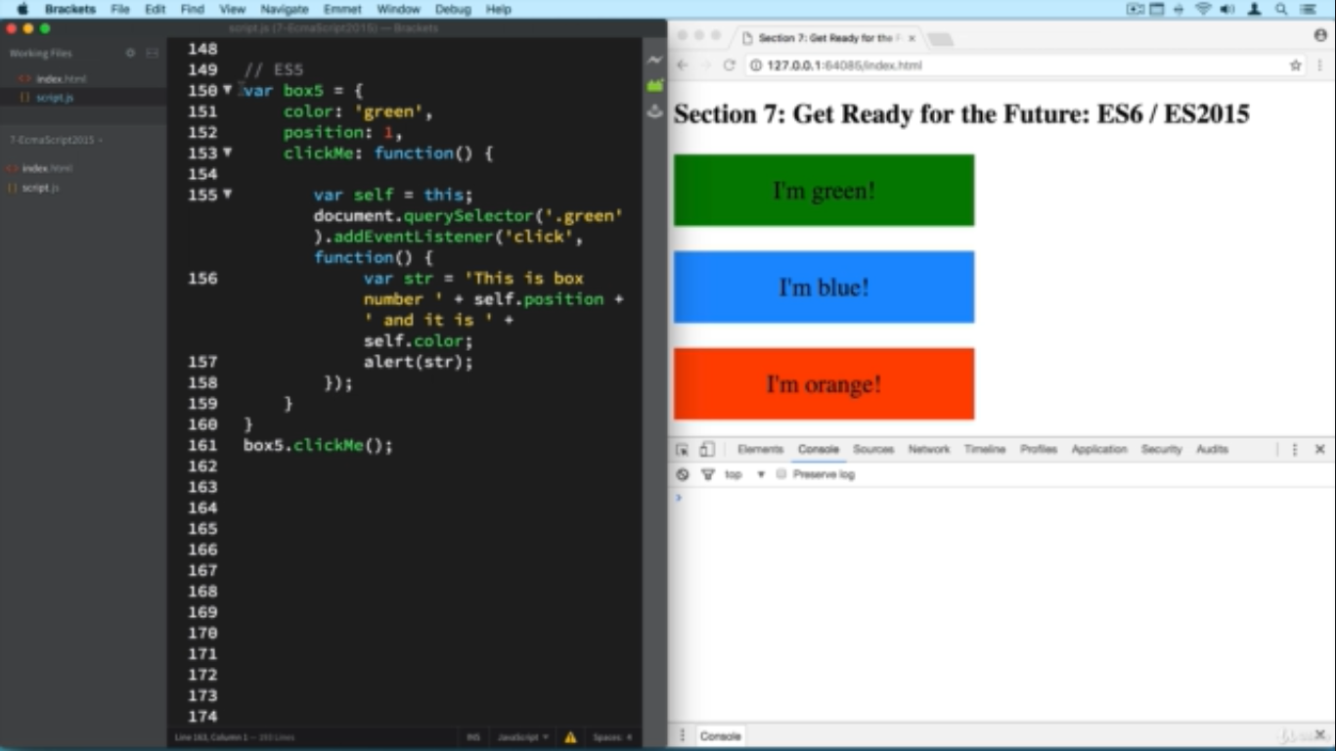

A nice work in ES6 to get around the above problem is use arrow functions

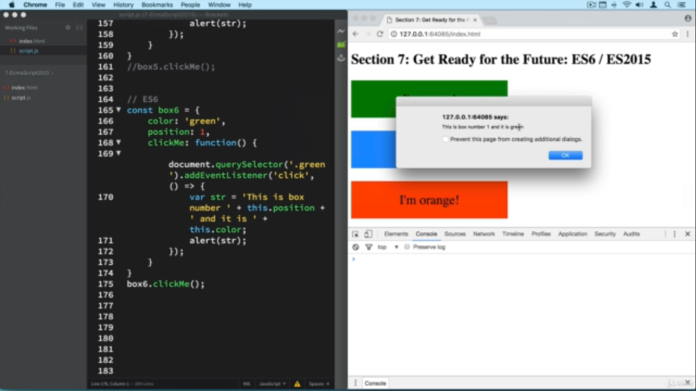

ES6 arrow function with prototype methods.

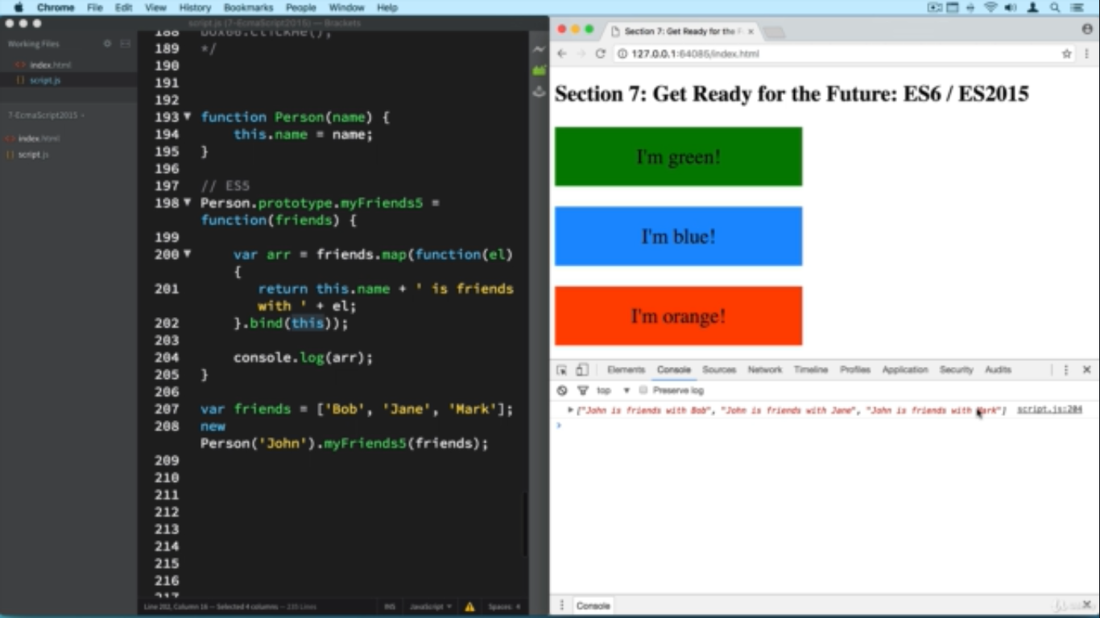

A short hand for above code is using arrow functions

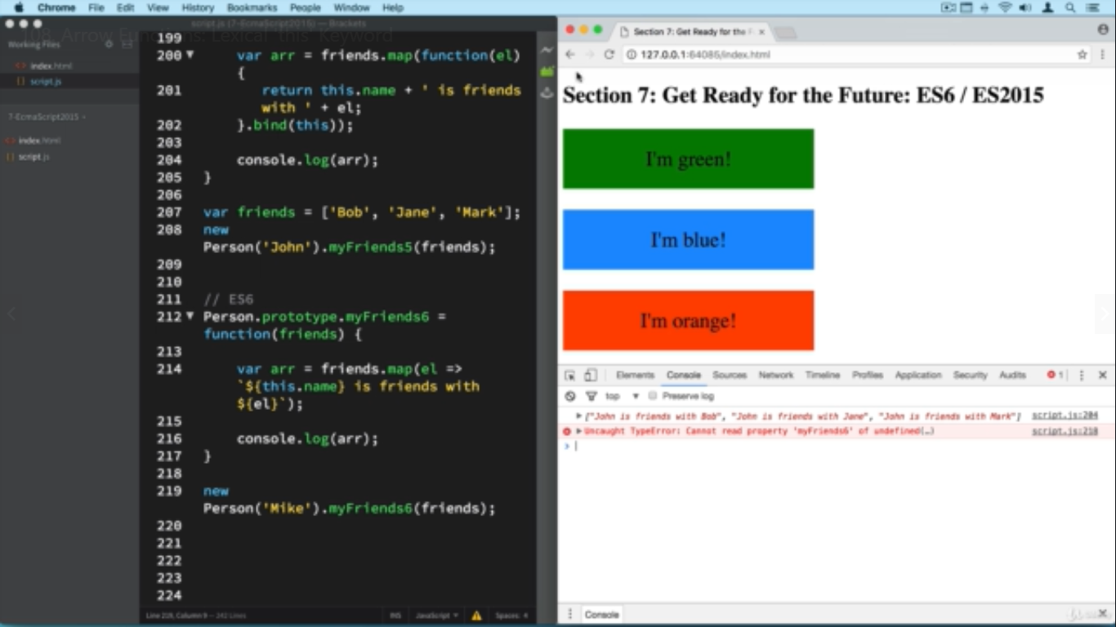

**DESTRUCTURING** is like tuple unpacking

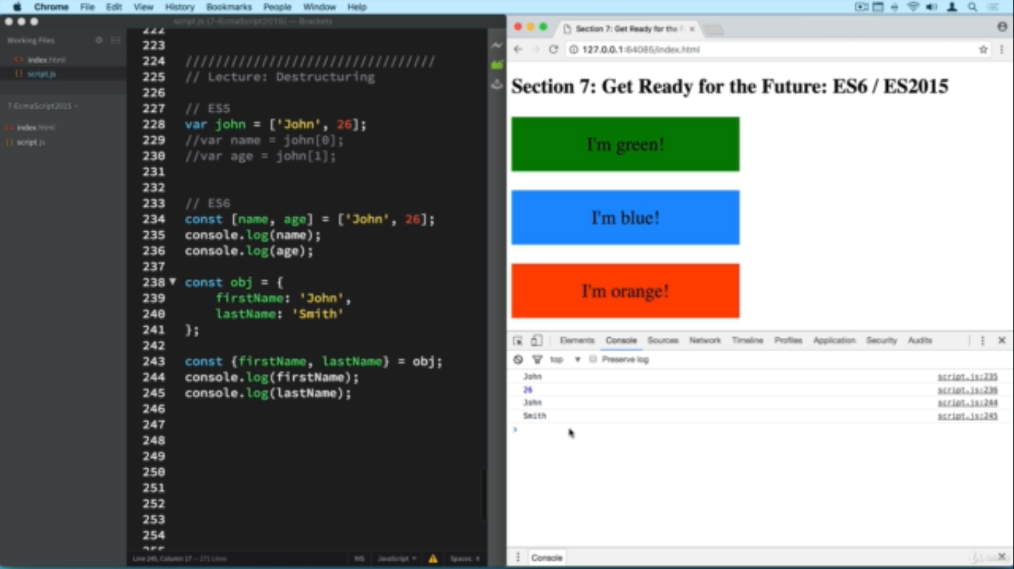

SPREAD OPERATOR

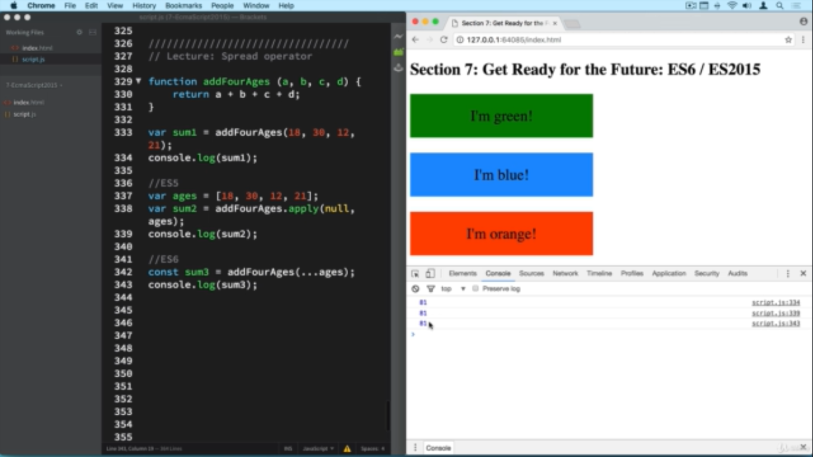

Another use case of spread operator to select all H1 tags on a page and change their color.

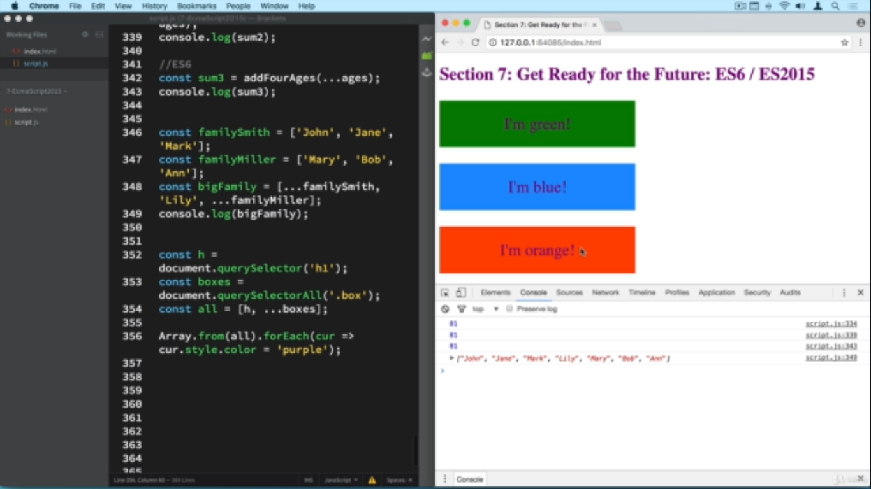

MAPS

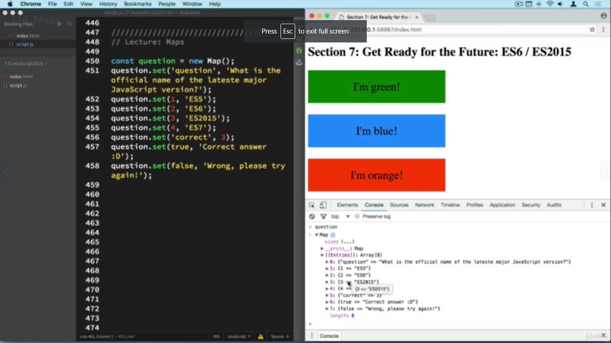

LOOPING THROUGH MAP

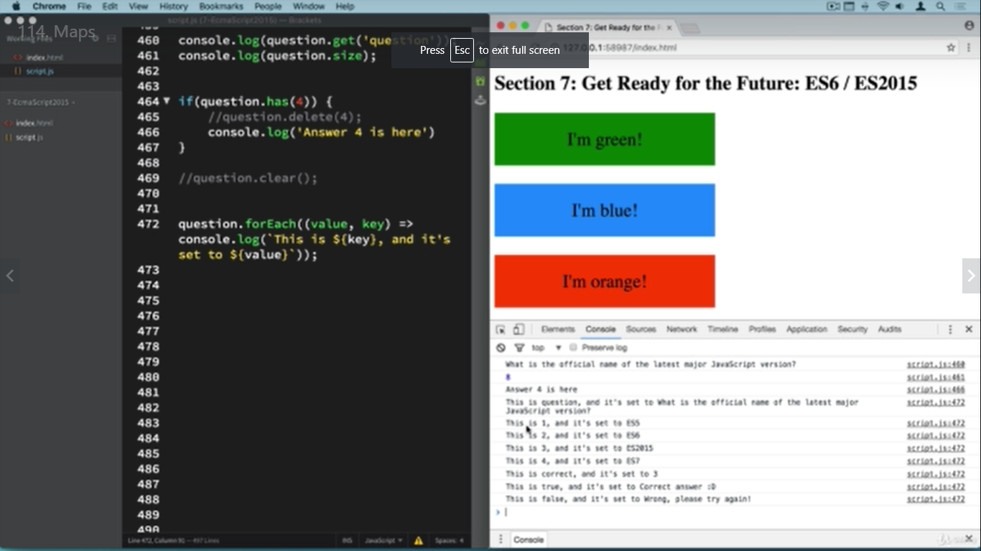

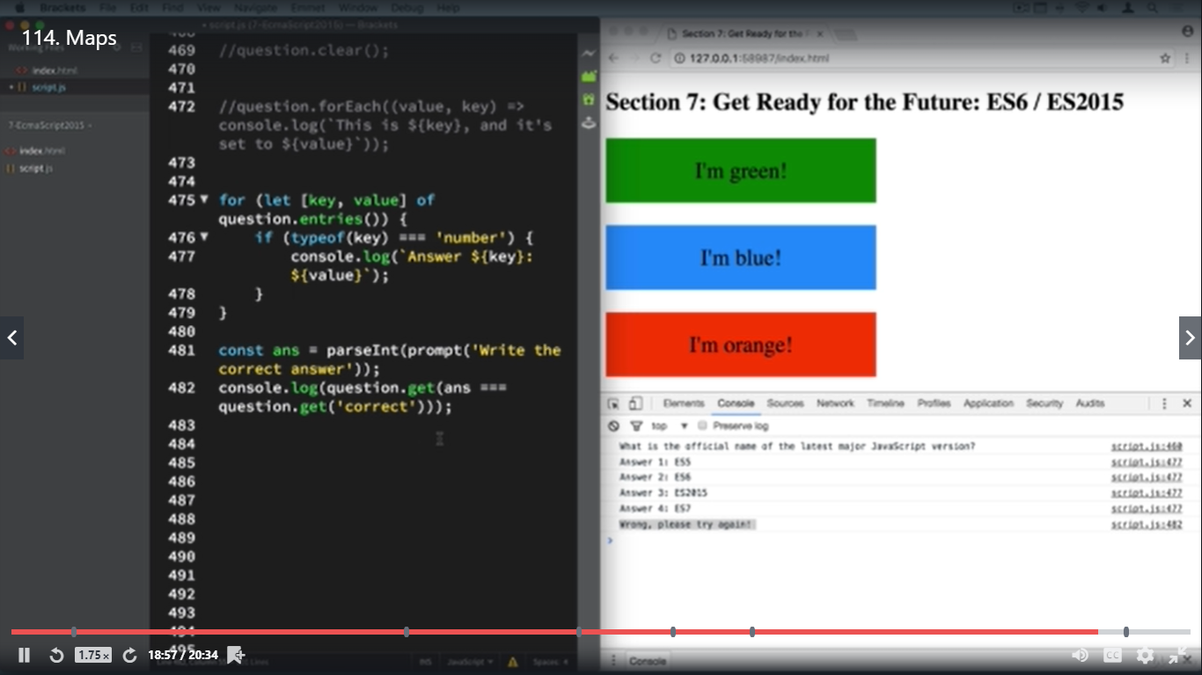

CLASSES

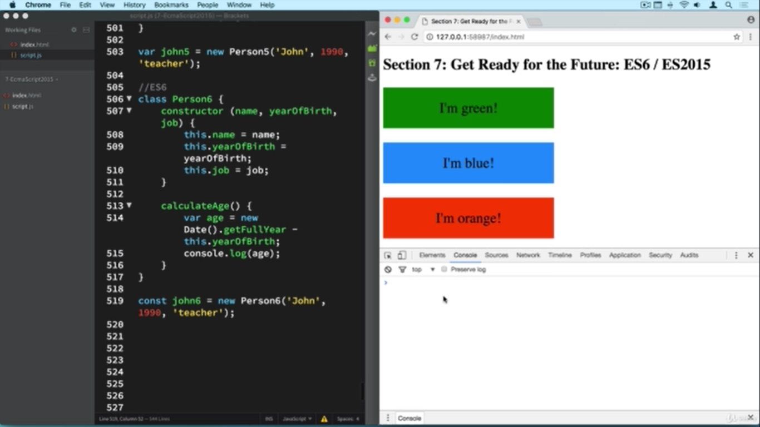

CLASS AND SUBCLASS

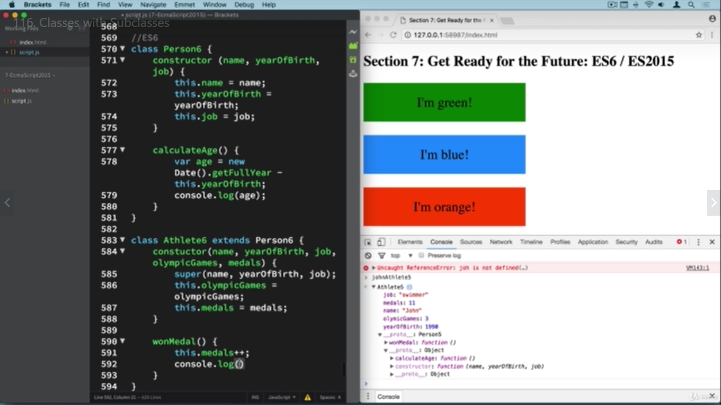

**AJAX**

Sample code

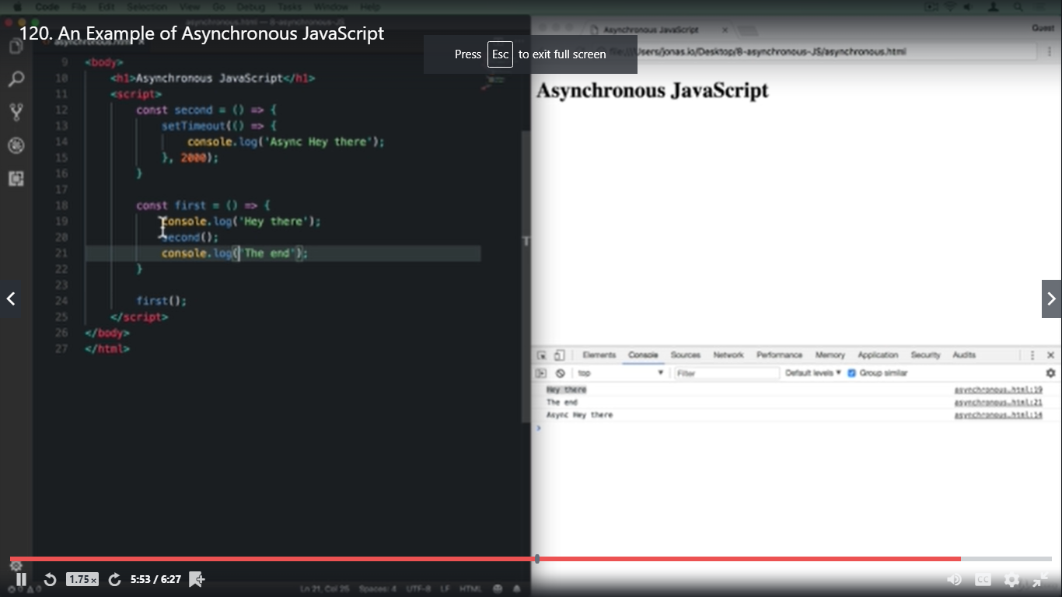

SYNC vs ASYNC

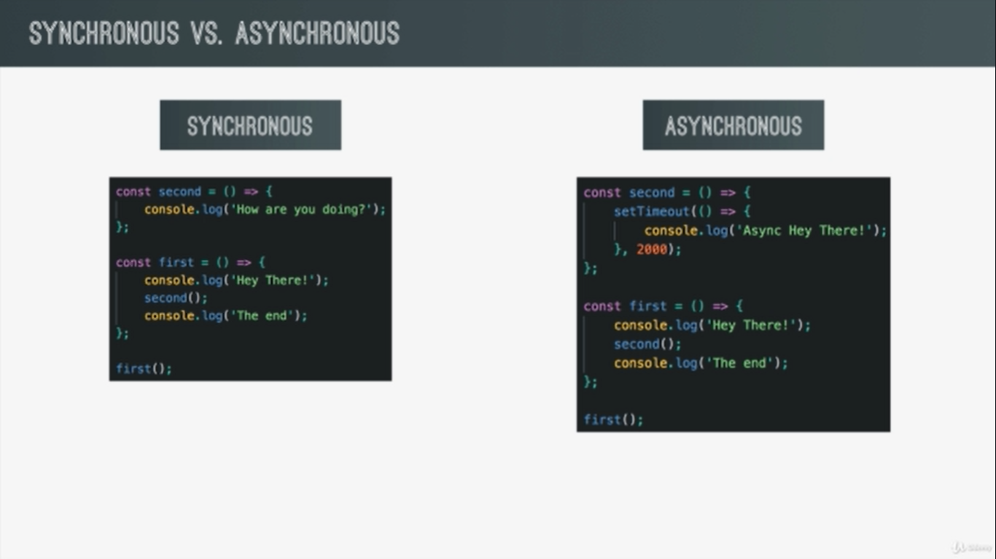

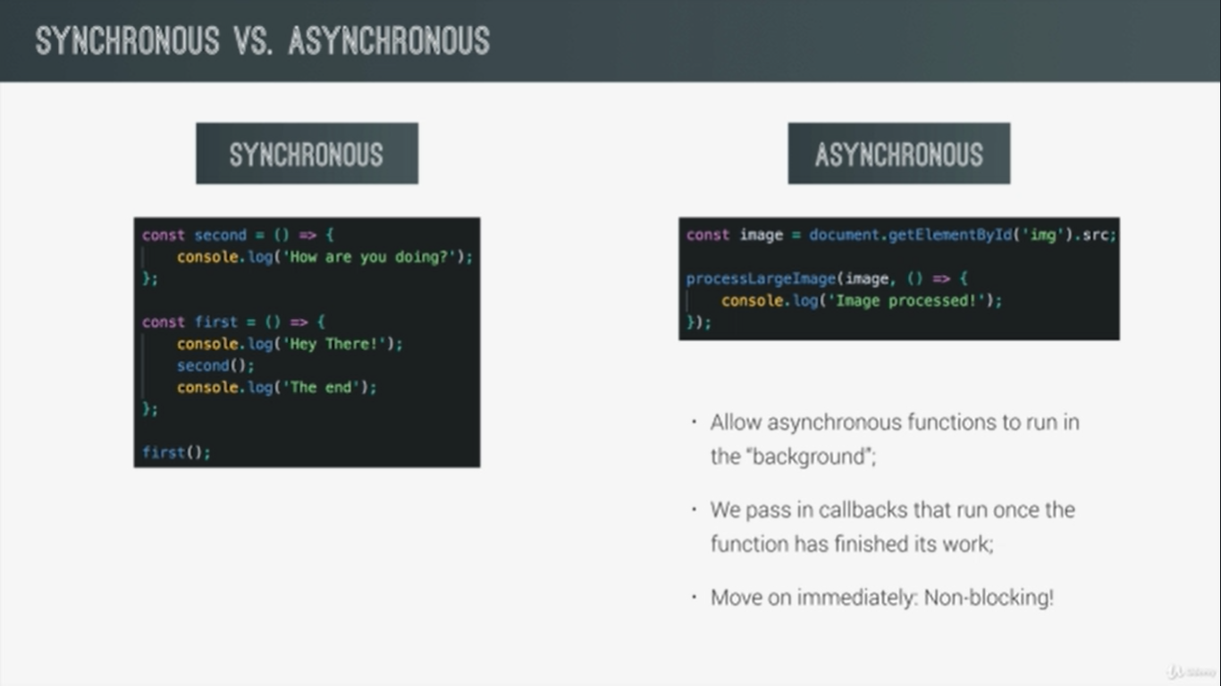

**PROMISE**

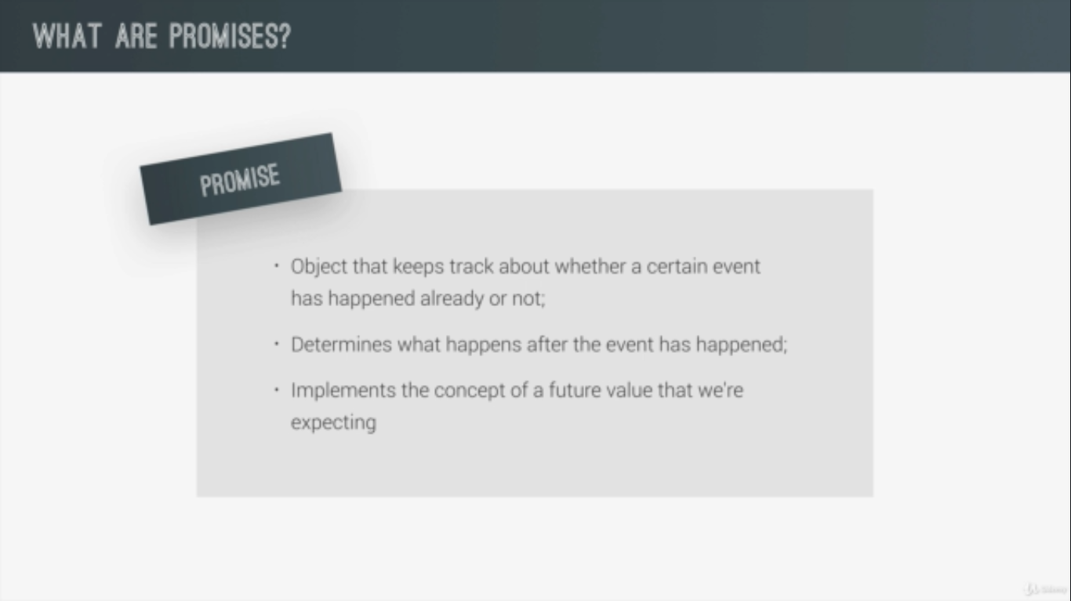

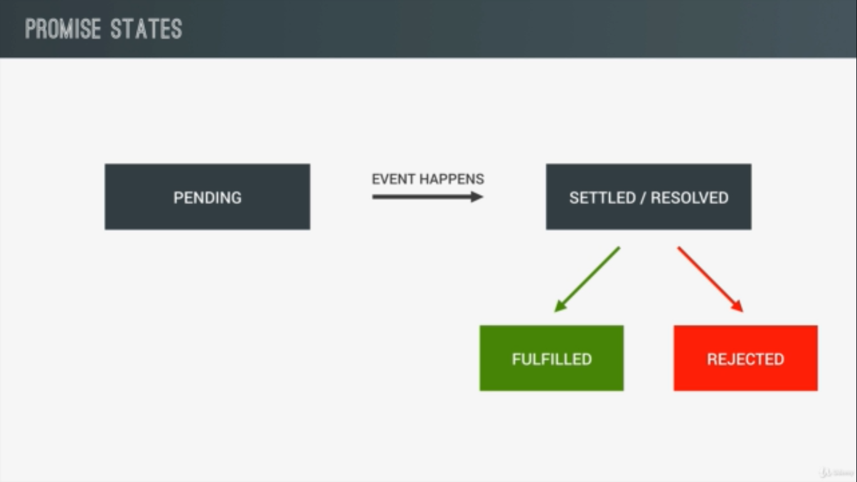

SIMPLE EXAMPLE OF PROMISE  
  
resolve argument is used to say that the result of the function was successful and the resolve output is available in the .then

reject argument is used when the promise failed and is used to send errors and needs to handled in the catch block

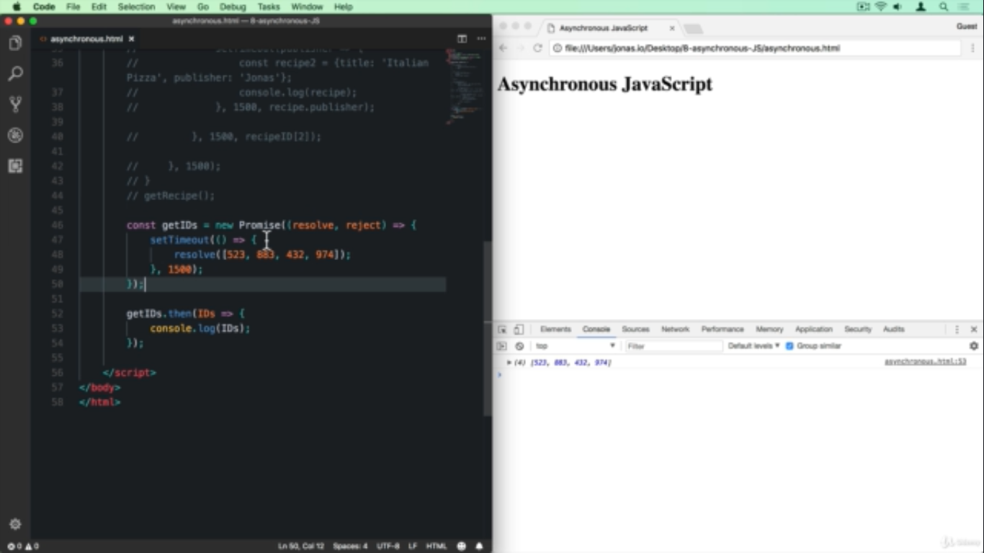

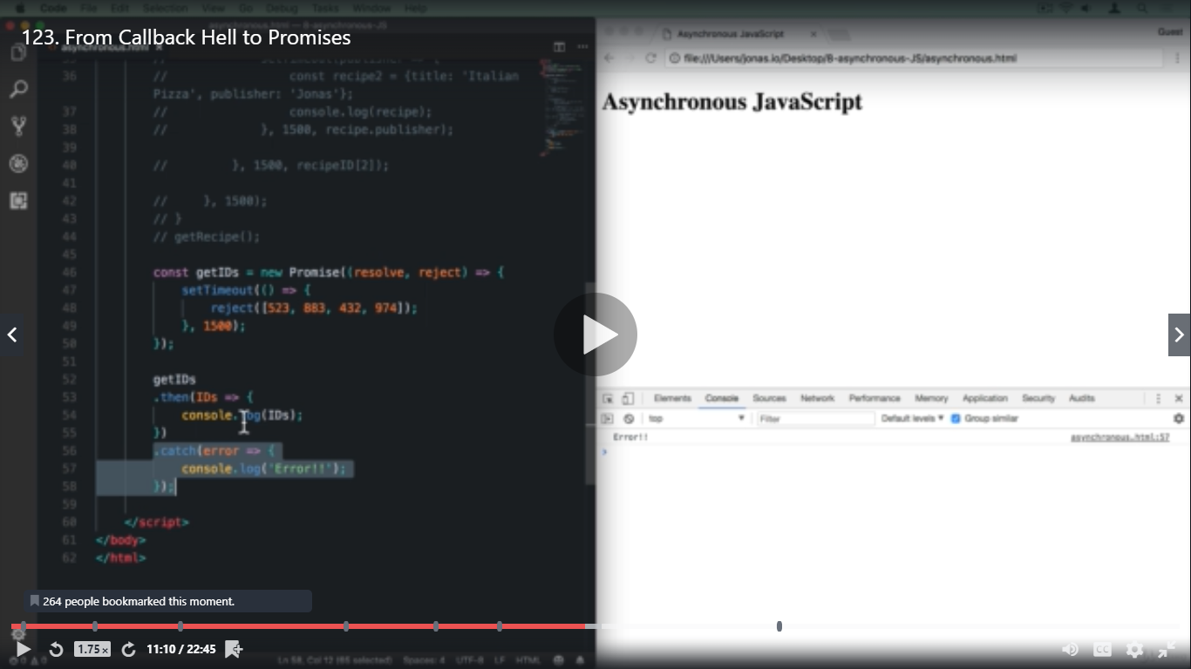

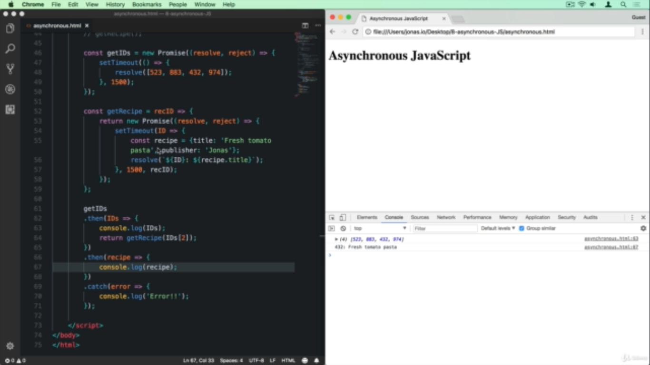

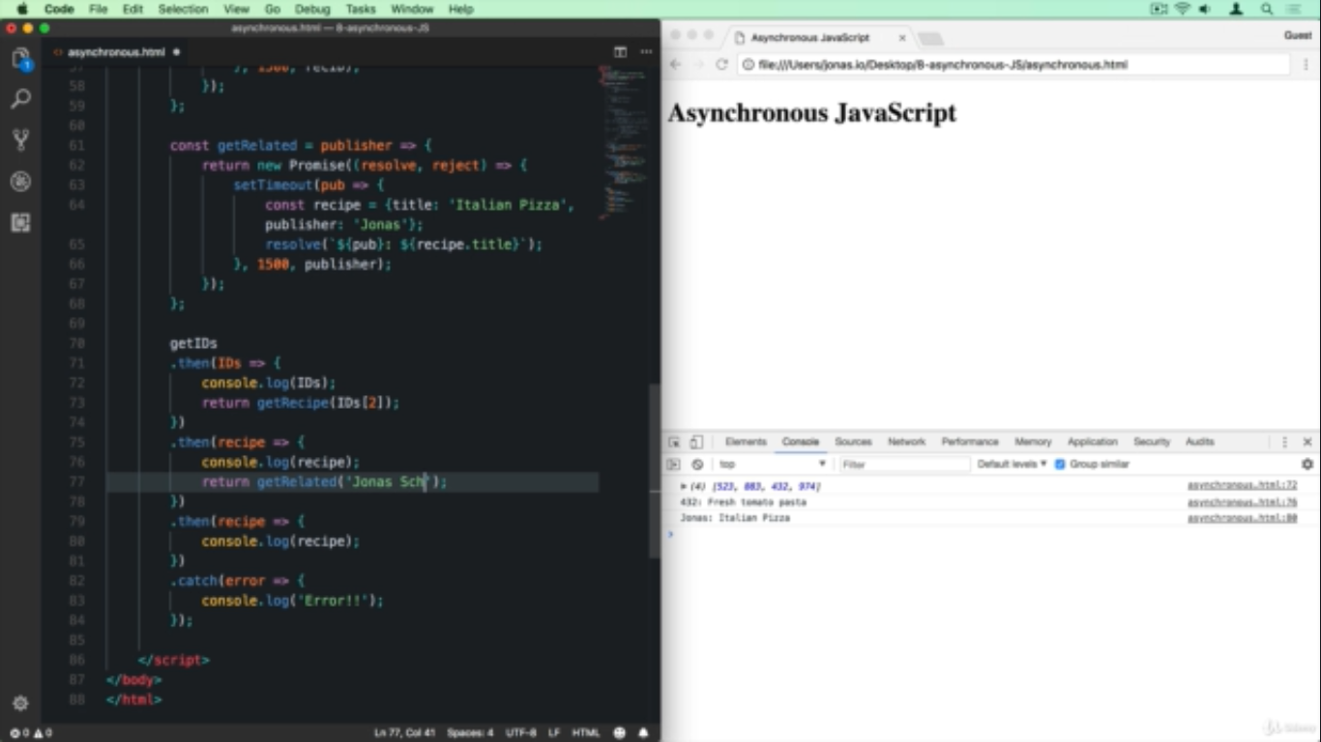

**ASYNC/AWAIT**

Notice here how the async function is used in place of earlier then and catch blocks

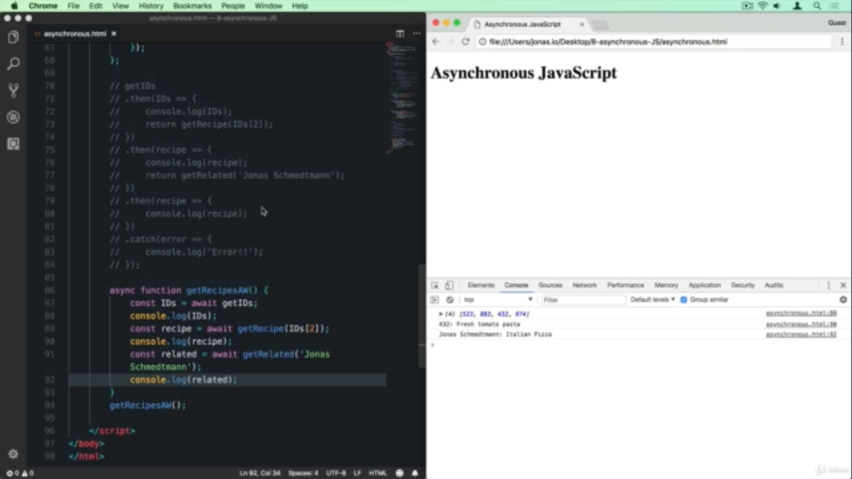

The fetch() method call

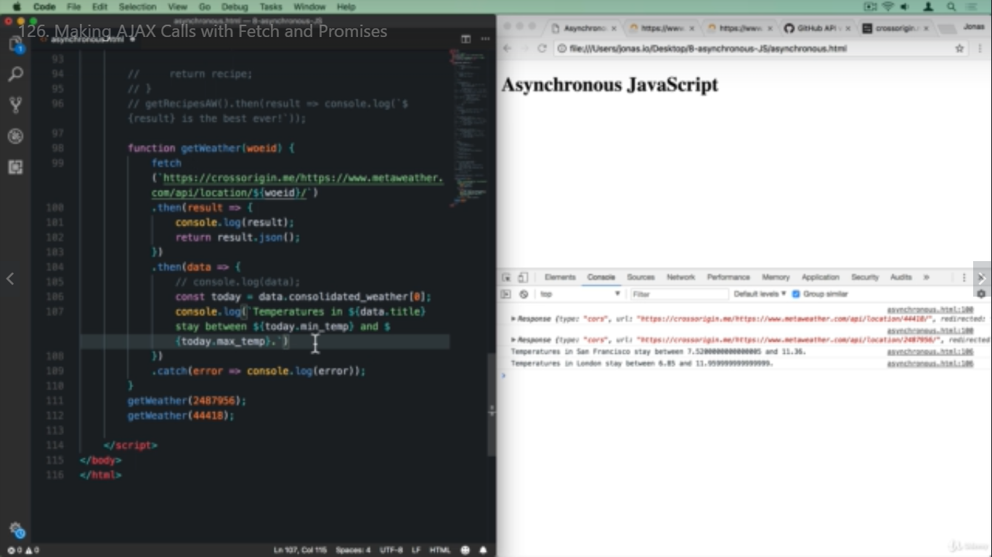

ASYNC AWAIT FETCH and try..catch

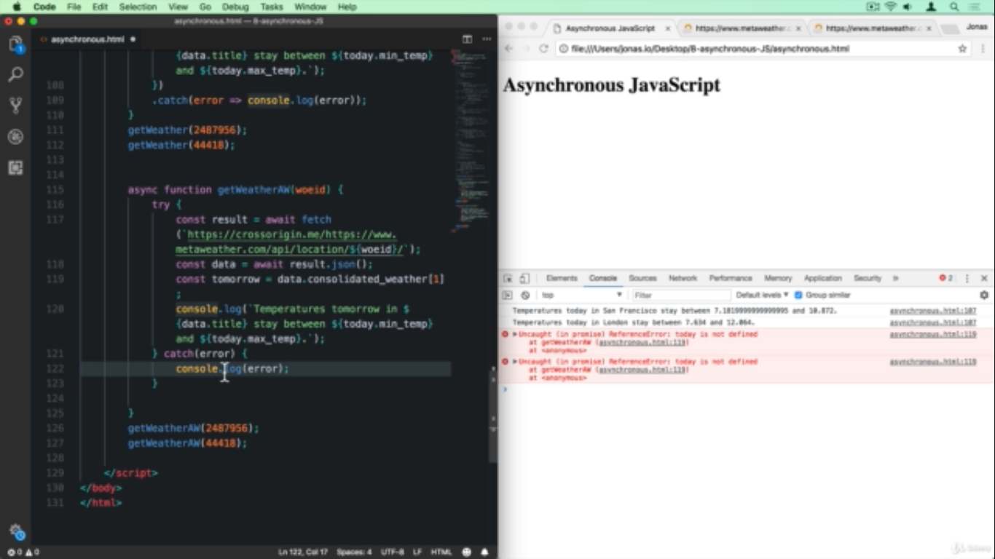

**MODERN JAVASCRIPT**

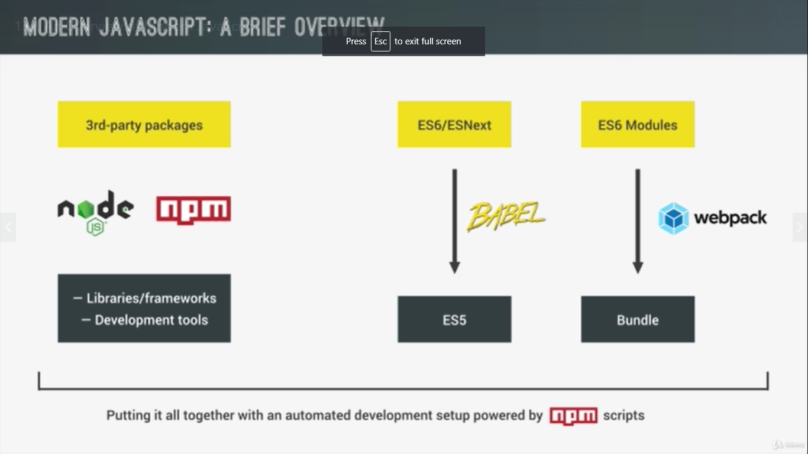

1. devDependencies are those which are required only for development and can be installed using npm install <package_name> --save-dev (webpack)
2. dependencies are those packages which are actually required to run our application and they can be installed as npm install <package_name> --save (jquery)

